Preface

This Guide explains how to create the reports using Crystal Reports. It is assumed that the reader has a good understanding of how to run the standard reports, since this is a prerequisite for using Crystal Reports to develop new reports.

Installation Notes

A standard installation, as described in the Installation Guide – Trade Innovation, must have been performed on a server and made available to use.

When you install Crystal Reports, make sure the option to install the JDBC/JNDI feature is selected.

The following sections refer to Crystal Reports XI.

If you are installing on Windows 7, you may need to set the compatibility mode of the Crystal Reports Designer for it to work using JDBC/JNDI. To do this, right-clicking on the shortcut and enabling the option to run in compatibility mode for Windows XP (Service Pack 3).

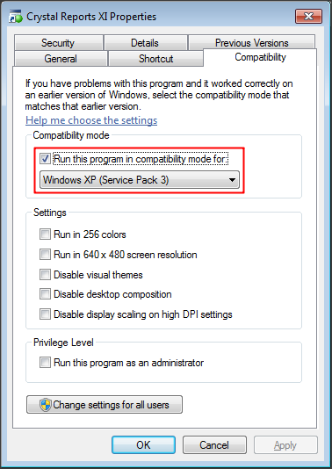

# Crystal Report Configuration

This chapter provides an overview of the process by which Crystal Reports are configured within your application server environment.

The following steps are involved:

* Initial Configuration
* Configuration for JDBC Connection
* Creating Reports through the JDBC Connection
* Enabling Java User Function Libraries
* Adding Reports into the system

These steps are described in the following sections.

1. When reports are executed, their embedded connection details are replaced with JNDI-based connection information. We do not advise using the JNDI connectivity feature for remote datasource access provided by the Crystal Designer. Support for this feature by the application servers supported is not consistent and is being removed in some cases. So when designing Crystal Reports, use a JDBC-based connection.

## Initial Configuration

The configuration described in this section must be carried out in order for Crystal Reports to be able to connect to a JDBC data source:

1. Install the Sun JDK version 6 (or later) on your local machine. Note, if you are using WebSphere, then install the IBM JDK that is delivered as part of WebSphere.
2. Install Crystal Reports on your local machine.
3. Copy the relevant JDBC driver jar files for the database you are using will be required (ojdbc6.jar for Oracle, db2cc4.jar for DB/2).

## JDBC Connection Configuration

The next step is to set up the CRConfig.xml file. This file is a configuration file that is needed by the Crystal Reports Designer to initialize the properties needed to use JDBC connectivity. In a Crystal Reports XI default installation, this file is found at the following location:

C:\Program Files\Common Files\Business Objects\3.0\java

### Data Driver Common Properties

The following elements need to be set in the <DataDriverCommon> section:

1. Set the <JavaDir> tag. This tag defines the fully qualified physical path to the Java SDK you are using for the JDBC connection.
2. Set the <Classpath> tag. This tag specifies the location of the Crystal Reports JAR files. Add entries for the JDBC driver jar files.
3. Set the <IORFileLocation> tag. This tag defines the path to where the Crystal Reports temporary files are written. By default, this is set to the same folder as the Temp environment variable.
4. If you meet problems when trying to create a JDBC connection in Crystal Reports, check that the physical paths and the environment variables are correct in the CRConfig.xml file.

### JDBC Connection Properties

The elements referred to in this section are in the <JDBC> section.

These are optional, however since the same database is likely to be used when designing multiple reports, these properties provide a default for the Crystal Report Designer. See the Crystal Reports documentation.

Set the <JDBCURL> tag. This tag specifies the URL for your database server connection.

For Oracle, this is:

jdbc:oracle:thin:@<dbserver>:1521:<db name>

For DB2, this is:

jdbc:db2://<db server>:50000/<db name>

Where <db server> is the host name of the database server, and <db name> is the name of the database to connect to.

The port numbers specified are the defaults used. These may need to be verified for your database setup.

Set the <JDBCClassName> tag. This the java class name of the JDBC database driver.

For Oracle, this is oracle.jdbc.driver.OracleDriver.

For DB2, this is com.ibm.db2.jcc.DB2Driver.

## Creating Reports through the JDBC Connection

This section demonstrates the steps in creating a report that uses a JDBC data source in an application server. The example uses Oracle.

1. Launch Crystal Reports.
2. In Crystal Reports, select the File|New|Blank Report menu option. The Database Expert dialog box appears. Expand the Create New Connection folder.

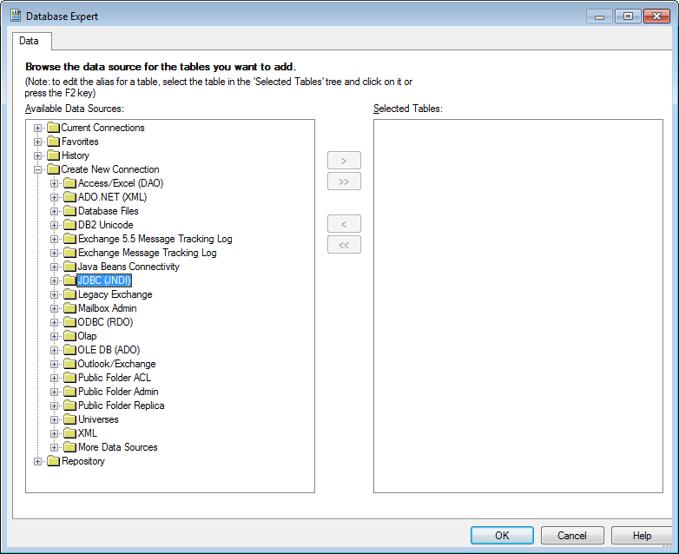

1. Double-click JDBC (JNDI). The JDBC (JNDI) Connection dialog box appears.

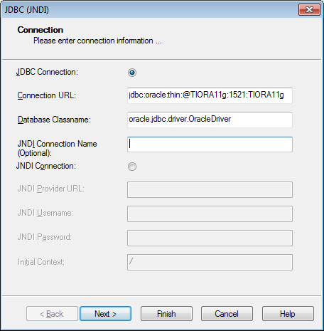

1. Verify that the connection details are correct – they should be the same as those set up in the CRConfig.xml file. At this point you could change these values, however they will not be stored in the CRConfig.xml file.
2. Click **Next**. The JDBC (JNDI) Connection Information dialog box appears.

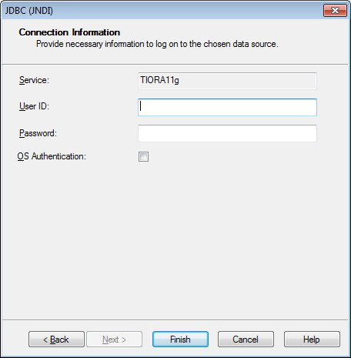

1. Enter a user id and password to access the database referenced in the previous dialog.
2. Click **Finish**.
3. Click **Finish**. The Database Expert appears with all the tables available to your report. This means Crystal Reports successfully connected to the JDBC resource and you can now start designing your report.

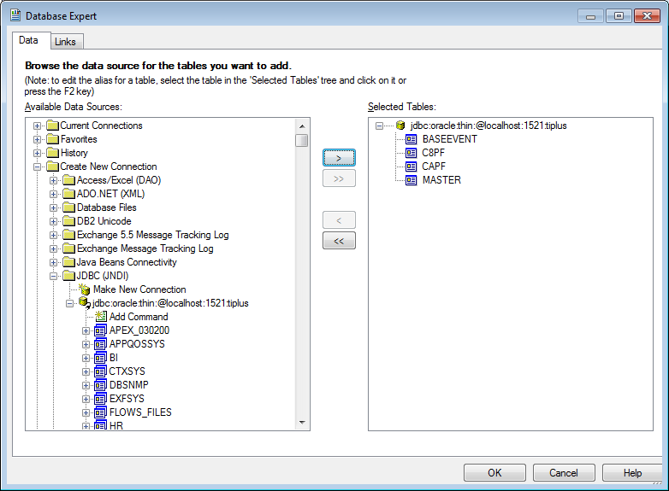

Once the connection has been set up, it is worth adding it to your favourites list – this will help re-using the connection later.

## Enabling Java User Function Libraries

The system features a user function library for use with Crystal Reports. It is located in the jar platform-zone-reporting.jar which needs to be made available to Crystal Reports Designer.

To allow Crystal Reports to make use of the Finastra-supplied User Function Library, first set up its environment.

### Setting Up the Java Environment

1. From the released software image, take the file platform-zone-reporting.jar from the folder /software/components/system/lib
2. copy this file to a suitable location on the file system that Crystal Reports Designer has access to,
3. navigate to C:\Program Files\Common Files\Business Objects\3.0\java\lib and locate the following files:

* CrystalFormulas.jar
* CrystalReportingCommon.jar
* u211java.jar

1. copy these files to the same folder as the jar file platform-zone-reporting.jar,
2. navigate to C:\Program Files\Common Files\Business Objects\3.0\java\lib\external and locate the following files:

* log4j.jar
* icu4j.jar

1. and copy these files to the same folder as the jar file platform-zone-reporting.jar as well,
2. add these files and platform-zone-reporting.jar to your classpath,
3. open RegEdit and navigate to the key HKEY_LOCAL_MACHINE\SOFTWARE\Wow6432Node\Business Objects\Suite 11.0\Crystal Reports. This assumes that you are running a 64-bit version of Windows. If not, the key will be HKEY_LOCAL_MACHINE\Software\Business Objects\Suite 11.0\Crystal Reports.
4. add a string value called JREPath. Set its value to the location of your Java runtime, e.g. C:\Java\jdk1.6.0_45\jre\bin\client\jvm.dll, and click OK to confirm.

### Setting CRConfig.xml

Locate the file CRConfig.xml, which will be in the folder C:\Program Files\Common Files\Business Objects\3.0\java in a Crystal Reports default installation.

Add the function classname to the section ExternalFunctionLibraryClassNames, as follows:

<ExternalFunctionLibraryClassNames>

<classname>

com.misys.tiplus2.platform.zone.reporting.functions.crystal.TIPlusCrystalLibrary

</classname>

</ExternalFunctionLibraryClassNames>

Make sure that you restart Crystal Designer, if it is running, before performing the next step and continuing.

### Enable Java User Function Libraries in Crystal

The Java User Function Library functionality then has to be enabled in Crystal Designer. To do so:

1. start Crystal Designer and open the Options dialogue box from the File menu,
2. select the Formula Editor tab, set UFL Support to Java UFLs Only,
3. click OK to confirm the change.

Crystal will prompt you to restart the application. Once you have done this, you should be able to use the User Function Library supplied. It is available from the Formula Editor in the Functions tree, in the section Additional Functions. (See Appendix D Configuring Crystal Designer to Use Java User Function Libraries.)

The User Function Library supplied currently contains the function converttotimezone, which converts a UTC timezone to a specified timezone and is used in reports that show event-related data such as diaryexceptions.rpt.

converttotimezone takes two parameters:

* a timezone string in the form "yyyy-MM-dd-HH:mm:ss" (the year as 4 digits, the month as 2 digits, the days as 2 digits, the hours as 2 digits, the minutes as 2 digits and the seconds as 2 digits, with the separators indicated),
* a Java-compatible timezonespecifier, e.g. "Europe/London" or "GMT+08". The formula UserTimeZone passes the timezone of the user in this format and is intended for use with this function.

1. The principal UTC timestamps used by the system are accessible via views that Finastra supplies, for example eventtstamps and steptstamps. These views are described later in this document.

## Adding Reports

After finishing a reports design, it should be added to the root of a jar file, and included in the local module in the software assemble environment. See the Installation Guide for more details on the local module.

The jar file you create will be added to the classpath automatically, and once the report is defined in the system, the Crystal Runtime Java runtime will pick the report up from the classpath.

# Creating Crystal Reports

This chapter provides an overview of the process by which reports are created using Crystal Reports, then incorporated into the system and tailored.

Subsequent chapters provide a detailed explanation of the process.

## Reports in Trade Innovation

Finastra uses Crystal Reports to design all the standard reports that are supplied as part of the system. The standard reports use JDBC to access all the data required for the report. They have a filename extension of 'rpt' and can contain links to any of the tables within the data model.

There are two stages in the creation of a new direct report:

First, the layout of the report is designed using Crystal Reports, as described in Chapter 3.

The report is then incorporated into the system, so that users can access and run it. In doing this, the report can be tailored to allow users to set criteria to select the information that is to be included in the report each time it is run. This is described in Chapter 4.

### Designing Reports

Crystal Reports permits you to define which data items are to be included in the report, how they will be arranged on the page, how they will be grouped or sorted, and the format of individual items of data. You can also create and apply formulae to data items to provide calculated values.

Crystal Reports also allows you to define the layout of the report, including page size and orientation, headings, footers and page breaks, the fonts to be used, and other visual presentation elements.

See Chapter 3 for more information on designing reports in Crystal Reports to be run from within the system.

### Incorporating Reports into the System

Once you have designed a report, you must then use the system tailoring application to incorporate it into the system so that it can be accessed and run by the users.

In doing this, you can also tailor the report by defining filters that can then be used when run ad-hoc within the zone to select the data that is to be included in that report.

The report can also be included in processing cycle end of days, as explained in the Business Operations Guide – Trade Innovation.

See Chapter 4 for instructions on incorporating reports into the system, including defining filter fields.

When a user selects a report in order to run it, the system displays a window that includes a number of filter fields. (See Chapter 4 for instructions on attaching filters to reports.) The user can enter values into these fields to select the data that is to be included in the report.

The system is delivered with a number of general-purpose filter fields which you can attach to a custom report so that they appear when the user runs your report. In addition the system also permits you to define three additional fields - two of them drop-down lists, the third an input field - which can be attached to a custom report in the same way. These can be used to make selections not supported by the standard fields.

See the Reports – Trade Innovation manual for full instructions on running reports.

# Designing Report Layouts

This chapter explains how to use Crystal Reports to design reports.

## Getting Started

Before you start designing reports, there are a number of steps that you need to carry out to ensure the data model is accessed correctly.

Crystal Reports expects to physically connect to the database being used when creating reports. This means that you must:

* Decide which database zone is to be used to set up reports
* Run at least one of the standard reports from this database zone. It is recommended that you run the System Tailoring report as it is a direct report (an .rpt) that reports from an area of the system that includes data after configuring the system. Failure to carry out this step will mean that errors will occur when you try to develop new reports from the database zone because various registry settings will not have been set up for you

## Running a Standard Report

The standard reports are provided in the software release in a jar file called platform-zone-reporting-files.jar located in the /software/components/system/lib folder of the release software. This can be expanded using any zip utility into a local folder.

After opening the report file (mappings.rpt), you will need change the data source location for each table from the report definition to your JDBC connection.

Select the menu option Database|SetDatasource Location... Expand your JDBC connection from the favourites list in the bottom window of the panel shown.

For each table listed in the Current Data Source window, select the equivalent in the schema for your JDBC connection.

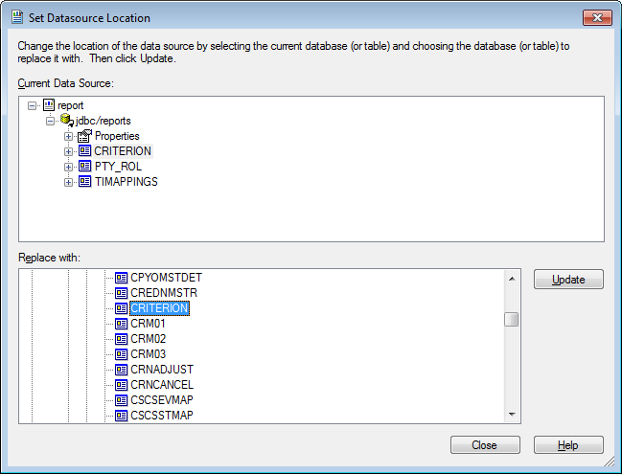

Click Update. Repeat for the remaining tables.

Once this has successfully been done, you should be able to run the report against your JDBC connection.

## Creating New Reports

For reports created in Crystal Reports to run successfully from within the system, they must contain the formulae listed in the table at the end of this section. For this reason it is recommended that, when you create a new report in Crystal Reports, you base it on an existing report of the same type.

1. Reports not developed in this way may result in formula errors when you try to run them from within the system.

Each of these formulae has a default value, shown in the table, which is used when you preview a report in Crystal Reports. When you run a report from within the system these default values are overwritten by values taken from the user's working environment, so their actual content in the saved Crystal Reports report layout file is not important. They should, however, return the correct type of value. They can be used in your report for display or calculations.

|  |  |  |  |
| --- | --- | --- | --- |
| Formula | Type | Description | Default Value |
| @ReportTitle | String | The name of the report. The name given to the report definition entry is used as the default, but can be overwritten in the Report Selections window in the system. | This varies with the report |
| @UserName | String | Filled in with the name of the user running the system. | User |
| @BaseCurrency | String | Code of the main banking entity base currency. | USD |
| @BaseEditCode | Integer | the number of minor units of the main banking entity base currency. | 2 |
| @LocalCurrency | String | Code of the main banking entity local currency. | USD |
| @LocalEditCode | Integer | the number of minor units of the main banking entity local currency. | 2 |
| @LocalCurrencyRate | Number | Spot rate for conversion from base to local currency. | 1.0 |
| @Other 1 | String | The code used for an additional run time filter option. | This varies with the report context |
| @Other 2 | String | The code used for an additional run time filter option. | This varies with the report context |
| @ReportingCurrency | String | Code of the reporting currency. | USD |
| @ReportCcyRate | Number | Spot rate of the main banking entity for conversion to reporting currency. | 1.0 |
| @RunOption | String | A formula specific to the report used, for example to display or hide optional sections. | This varies with the report context |
| @TIVersion | String | The system’s version number. | 2.0.0 |
| @UserTimeZone | String | Time zone offset to be applied to the UTC timestamp to reflect the user time. | Europe/London |
| @UnitName | String | The name of the zone on which the report is run. | EQx |
| @UnitDate | Date | The current date. | The Crystal built-in function PrintDate |

### Saving Reports

You should save reports to be run from within the report file directory used by the system. This is defined during installation. Ask your system administrator if you do not know where it is. The Crystal Reports File|Options - New Report menu option allows you to set the directory to which new files are to be saved.

The name of the file in which the report is stored should be 11 characters long or fewer, and should have the extension '.rpt', for example 'taxsummary.rpt'.

### Connecting to the Database

When you are ready to create a new report, follow the steps below:

1. Start Crystal Reports and select the File|New menu option.
2. The Database Expert window will be automatically opened. Open the Create New Connection option by clicking its plus sign on the left hand side of its folder.
3. Open the JDBC (JNDI) option by clicking its plus sign on the left hand side of its folder.
4. This opens the JDBC (JNDI) connection dialogue box. Verify the details including the JDBC Connection URL and Database Classname. These settings are populated from the file CRConfig.xml. Click Next and enter a User id and Password.
5. Click the Finish button. The Database Expert appears with all the tables available to your report. This means Crystal Reports successfully connected to the JDBC resource and you can now start designing your report.

Once you have connected to the database you can preview data, add and remove tables or update links without logging on again. However, when you exit Crystal Reports and then restart it, you will be asked again to log onto the database source when you next carry out any function that needs access to the database. This includes preview, adding or removing tables and browsing data field contents. Each time you log on you should confirm that you are connected to the correct database.

## Adding Tables and Views to a Report

Once you have opened a report, you can add tables and/or views to it using the Database| Database Expert menu option. When you select this menu option, Crystal Reports displays a list of data sources available on your PC. Select the JDBC (JNDI) option as described above.

1. To speed up subsequent use of this data source it is a good idea to press the Add to Favourites button to add it to the Favourites list.

You can select views as well as tables into a report. Views are handled in exactly the same way as tables by Crystal. They can be linked to other views and tables and the fields that they contain can be added to the report canvas as well as used in formulae.

After choosing all the tables or views you require pressing the Close button will bring up the Visual Linking Expert window to define the link between the tables included in the report.

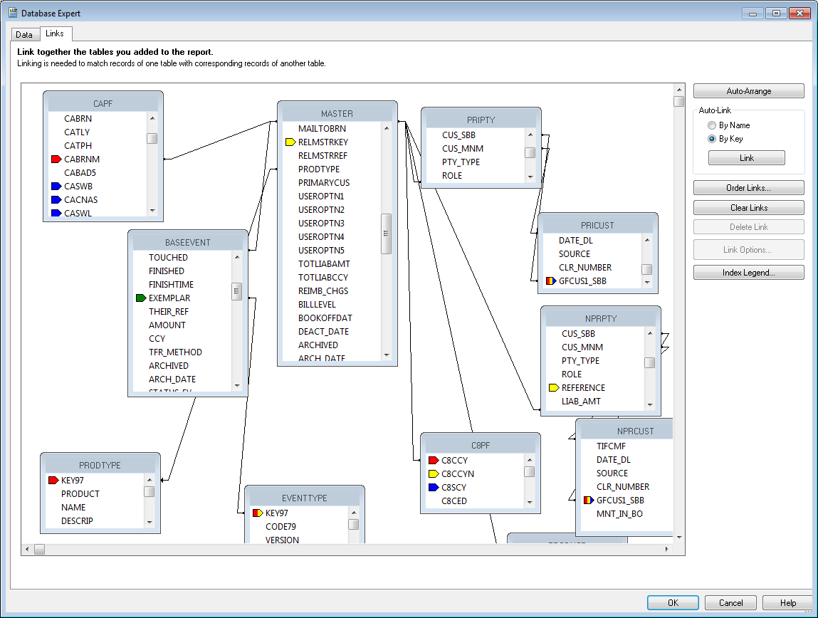

1. Finastra strongly recommends that you turn off the Crystal Reports AutoSmart Linking facility (using the File|Options - Database menu option) and link all tables manually. Once you have linked two or more tables, press the Arrange button in this window to reorganise the tables visually to reflect the new link(s).

### Linking Tables

This section provides hints on linking tables in the database whilst using Crystal Reports to design reports.

The Crystal Reports documentation set provides full instructions on linking tables within a report. You should refer to it as your primary source of information.

* If you use more than one table in a report, then they must each be linked to one of the other tables for the report to work. Crystal Reports will warn you if you leave any tables unlinked. The tables are linked from foreign key columns to primary key columns. Most tables have a primary key called KEY97 or KEY29, indicating that an auto-generated number is used as the key.
* Some tables have meaningful keys which may be single or multi-part fields. They are meaningful in that they are valid data which can appear on a report. For example, the key to the branch table (CAPF) is a branch code (CABRNM), which is often required on a report.
* Some foreign keys to tables have more than one column. For example, the foreign key to the customer table (GFPF) consists of a customer key (GFCUS1) plus a key to the source banking business that it belongs to (GFCUS1_SBB). You must link each part of the key column to the corresponding part of the foreign key column for the join between the two tables to be successful.
* The links you define in Crystal Reports must reflect the links defined in the data model. If they do not, then when the report is run it will retrieve no data.
* The direction of the link does not matter, but Finastra suggest that you follow standard design principles and link FROM the many table TO the one table.
* For some purposes, you may not need to link to another table at all, and the fewer links in a report, the faster it will run. The foreign key may contain the information you need. If all you need is a currency code, for example, you can simply add the foreign key column to the report rather than add the currency table to the report, for example the field CCY on the table MASTER.
* By default all joins between tables are inner joins. When the report is run, any rows that do not have matching values in the linked columns will not appear in the report. Most of the time this is exactly what is required but it is important to remember when linking to columns which are optional, or for which information may not yet have been entered, and so may be empty when the report is run.
* When you wish to have joins between foreign keys that are optional, then you must use the SQL feature called an outerjoin. In this case a row is returned for the report even when the foreign key is empty. To do this highlight the join line between the tables in the Visual Linking Editor and right click the mouse to see the Options context menu, then choose left-outer as the join type.

Crystal Reports versions 8 and later supports the ANSI standard for SQL version 3.0 in which multiple outer-joins are supported within a report.

#### Example

A report is required which lists events and shows for each event:

* Product name
* Master reference
* Principal name
* Event reference
* Event name

The tables required are:

* the table EXEMPL30 (for the product name)
* the table MASTER (for the master)
* the table EXEMPL30 (for the event name)
* the table BASEEVENT (for the event)
* the table PARTYDTLS (for the details of the Principal party)
* the view PRODSHORTNAME.

To create the report, follow the instructions given below:

Use the Database|Database Expert menu option to add the tables and the view listed above to the report. Note that the table EXEMPL30 is used twice, so it will need to be added twice. When more than one instance of the same table is required, Finastra recommends that it is renamed to reflect its use. To rename a table, right-click it and select Rename. In the example above, the instance of EXEMPL30 for the product name will be renamed to PRODUCT and the instance of EXEMPL30 for the event name will be renamed to EVENTTYPE.

In the Links window of the Database Expert, make the following links:

* from MASTER.EXEMPLAR to PRODUCT.KEY97,
* from PRODUCT.CODE79 to PRODSHORTNAME.PRODCODE,
* from MASTER.KEY97 to BASEEVENT.MASTER_KEY,
* from BASEEVENT.EXEMPLAR to EVENTTYPE.KEY97,
* from MASTER.PCP_PTY to PARTYDTLS.KEY97

Insert the following columns into the report:

* PRODSHORTNAME.SOVALUE
* MASTER.MASTER_REF
* BASEEVENT.REFNO_PFIX
* BASEEVENT.REFNO_SERL
* EVENTTYPE.SHORTN13

Finally, format the serial numbers and remove trailing decimal places and thousands separators.

The information retrieved into the report when it is run will look something like this:

ExportLC ELC00001002 PRE 001 PreAdvise

ExportLC ELC00001002 ADE 001 Advise

ExportLC ELC00001002 BKE 001 Bookoff

ExportLC ELC00001002 DPR 001 Docs Pres

ExportLC ELC00001002 AMD 001 Amend

ImportLC ILC00001009 ISS 001 Issue

ImportLC ILC00001010 ISS 001 Issue

ImportLC ILC00001011 ISS 001 Issue

ImportLC ILC00001012 ISS 001 Issue

ImportLC ILC00001012 COR 001 Correspond

ImportLC ILC00001012 CLM 001 Clm Rec'd

ImportLC ILC00001012 AMD 001 Amend

ImportLC ILC00001012 AJI 001 Adjust

ImportLC ILC00001013 ISS 001 Issue

ImportLC ILC00001014 ISS 001 Issue

To include the principal party from the master so that its full name can be included in the report, do the following:

Insert PARTYDTLS.ADDRESS1 into the report after the master reference number.

The information retrieved into the report when it is run will now look like this:

ExportLC ELC00001002 National Westminster Bank PRE 001 PreAdvise

ExportLC ELC00001002 National Westminster Bank ADE 001 Advise

ExportLC ELC00001002 National Westminster Bank BKE 001 Bookoff

ExportLC ELC00001002 National Westminster Bank DPR 001 Docs Pres

ExportLC ELC00001002 National Westminster Bank AMD 001 Amend

ImportLC ILC00001009 ICI Industries ISS 001 Issue

ImportLC ILC00001010 ICI Industries ISS 001 Issue

ImportLC ILC00001011 ICI Industries ISS 001 Issue

ImportLC ILC00001012 ICI Industries ISS 001 Issue

ImportLC ILC00001012 ICI Industries COR 001 Correspond

ImportLC ILC00001012 ICI Industries CLM 001 Clm Rec'd

ImportLC ILC00001012 ICI Industries AMD 001 Amend

ImportLC ILC00001012 ICI Industries AJI 001 Adjust

ImportLC ILC00001013 ICI Industries ISS 001 Issue

ImportLC ILC00001014 ICI Industries ISS 001 Issue

## Hints on Designing Reports

This section provides hints on avoiding problems when designing the reports in Crystal Reports.

In selection formulae use the format:

'LIV' in {MASTER.STATUS}

rather than:

{MASTER.STATUS} = 'LIV'

To avoid truncation of data when a report is printed you should leave additional space (how much depends on the printer you are using) at the right-hand edge of left-justified members and the left-hand edge of right-justified fields.

The physical positioning of fields can vary by up to 1.5mm between different laser printers. This is especially noticeable when using boxes and lines. To ensure that the layout of a report prints correctly, you should test it by printing it to the type of printer the end users will use.

When testing reports in Crystal Reports, use purposely large test values when printing to test the size of numeric fields.

When a report is run from within the system, the user is able to enter selection criteria into any filters attached to the report to determine which records are to be included. The user's criteria are added to any record selection formulae that you may have set up when designing the report using Crystal Reports and may conflict with them. It is therefore advisable to take care when defining record selection formulae and embedding them directly into a report.

If you need to use record selection formulae to restrict the report to certain records, then you can add the formula using additional conditions in the system (see page 31). Alternatively, you can create a record group in the report which includes the data you wish to display, and use the group selection formula to restrict the report to that group.

If you use the Report|Select Expert menu option, Crystal Reports automatically generates a record selection formula. You should therefore use the Report|Edit Selection Formulae menu option to check that there is no record selection formula in a report before saving it.

## Adding and Formatting Fields

Use the Database|Database Expert menu option to add columns from the database to a report layout. When you use this menu option, Crystal Reports produces a window listing all the columns in each table included in the report.

Once a column has been added, it can be formatted and edited using standard Crystal Reports facilities.

There are some special considerations you need to take into account when working with fields of type string, logical and date, and with fields used to display monetary amounts.

### String Fields

String columns may not be in the correct format for display. Some string columns consist of a code which will need to be converted to a more user-friendly format.

For example, transfer methods are identified using the following values:

|  |  |
| --- | --- |
| Stored Value | Display Value |
| 1 | Mail |
| 4 | SWIFT |

### Logical Fields

Logical columns store Yes/No values, for example to indicate whether a posting is to a contingent account or not, or whether it has rules attached to it or not. These columns should be treated as string members when designing reports using Crystal Reports. These can have one of two values:

|  |  |
| --- | --- |
| Y | (= true) |
| N | (= false) |

You can use a formula to expand the display value, so that it appears in the report as 'YES' or 'NO'.

### Date Fields

All reports should be defined as using the default locale setting for dates. This setting can then be controlled in one place using the Windows Control Panel. ?????

All standard reports use the Short Date Style and are therefore designed to provide sufficient space for dates in one of the following formats:

DD/MM/YY

MM/DD/YY

DD/MM/YYYY

MM/DD/YYYY

A space, a hyphen or a dot may be used in place of the forward slash, in line with regional preferences.

### Timestamp Fields

Timestamps are handled as the Crystal DateTime type which includes a date and a time part. They can be formatted to show only the date, the date and the time, or only the time using Crystal's built-in formatting options. The User Function Library function converttotimezone returns a DateTime so that the values that it returns can be formatted in the same way as timestamps.

### Number Fields

If you insert a number directly into a report design using Crystal Reports, it will be displayed by default with two decimal places, which will always be zeros. To display monetary amount members correctly, you will need to apply a formula based on the currency, as described below.

### Monetary Amounts

Monetary amounts are stored in the database as integers in minor currency units. In order to display them correctly, you must use a formula to determine the number of minor currency units and calculate the value to be displayed.

This may be done by linking the associated currency code to the table C8PF and including the column C8CED in the report, or otherwise the view CCYDTLS and including the column CCY_CED. It is then possible to write a formula to calculate the correct number of decimal places to display the amount with.

1. See the Crystal Reports user documentation set for instructions on creating and editing formulae.

For example, to calculate the master amount with the correct number of decimal places:

Include the table C8PF in the report,

Link C8PF.C8CCY to MASTER.CCY,

Add a formula called MasterAmount.

In this formula, add the text

{MASTER.AMOUNT} / (10 ^ ToNumber({C8PF.C8CED}))

Or, using CCYDTLS, add the text

{MASTER.AMOUNT} / (10 ^ ToNumber({CCYDTLS.CCY_CED}))

to the formula MasterAmount.

#### Using Functions

When you select the Edit|Formula menu option to format a formula field, Crystal Reports allows you to access user-defined functions for inclusion in the formula. These functions are listed in the Functions panel of the Edit Formula window, where you can select them for inclusion in your formula.

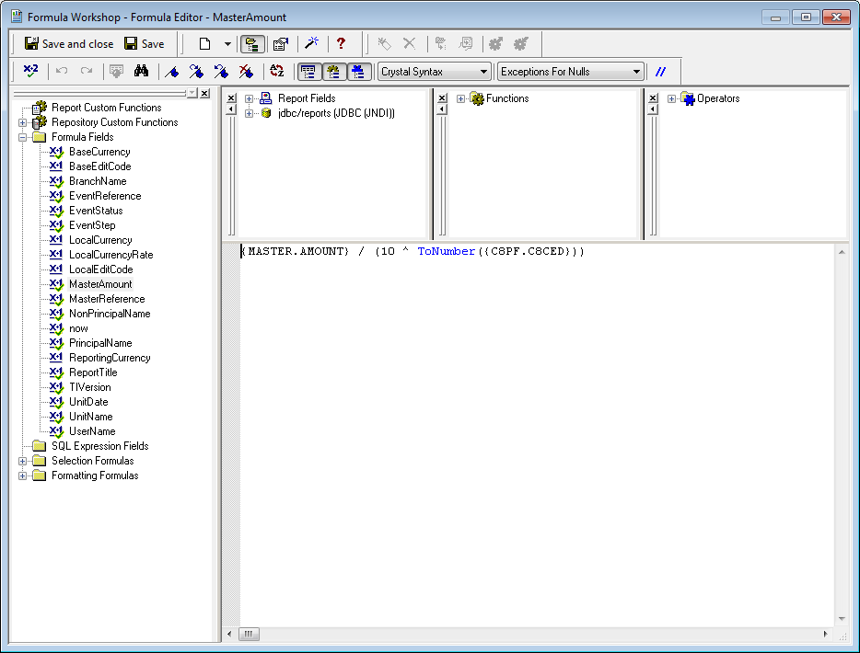

SAP supply a standard set of these functions both of their own and third party ones that they feel will benefit Crystal Reports users.

Crystal Reports formulae do not support the use of arguments. This means that you will need to copy and paste the code to calculate the amount between each formula that requires it.

NumberVar editCode := ToNumber(C8PF.C8CED);

NumberVar rtnAmount := {MASTER.OUTST_AMT} / (10 ^ editCode);

rtnAmount;

This formula can be written for one field that will appear in the report, then copied and pasted for any other fields. Only the database column names for the underlying table columns need to be amended.

Alternatively, you can use a report custom function to ensure that the same code can be reused wherever required.

To create a report custom function:

Open the Formula Workshop, then right-click Report Custom Functions in the list on the left-hand side of the window,

Select New, which opens the Custom Function Name dialogue box. Enter the name of the function to be created, then click Use Editor.

This opens the function editor with the following empty function definition text.

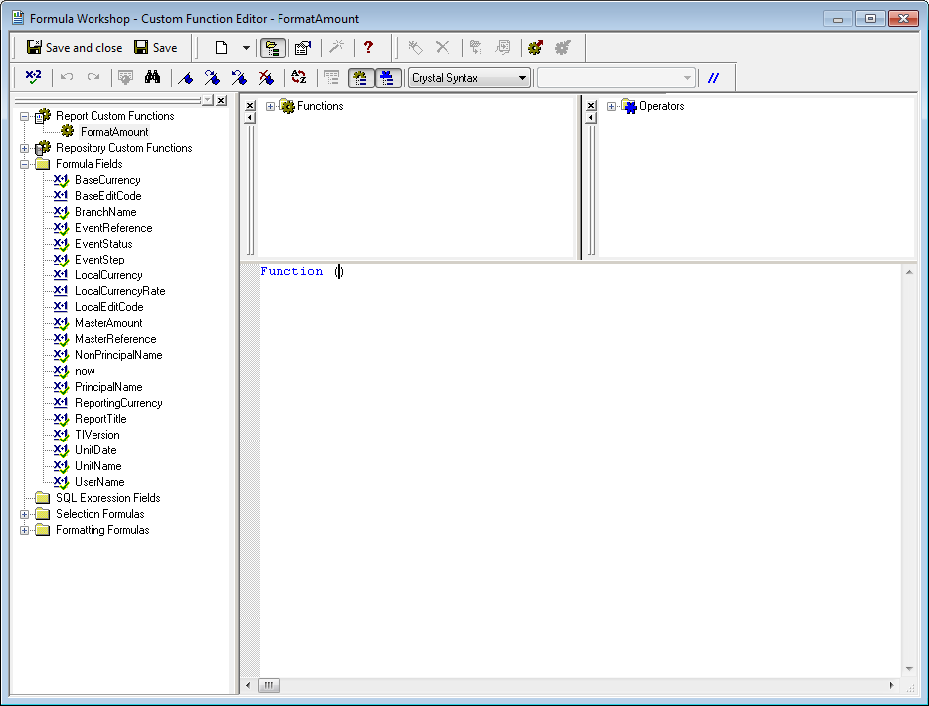

Add any parameters with their types between the brackets, e.g.

Function (StringVareditCode, NumberVar amount)

then add the body of the function which will perform the calculation required. The format and syntax are the same as for a formula:

Function (StringVareditCode, NumberVar amount)

NumberVardecimalPlaces := ToNumber(editCode);

NumberVarrtnAmount := amount / (10 ^ decimalPlaces);

ToText(rtnAmount, decimalPlaces);

Click Save and Close when finished.

The function can now be used in formulae as required:

FormatAmount(C8PF.C8CED, {MASTER.OUTST_AMT});

# Incorporating Reports into Trade Innovation

This chapter explains how reports designed using Crystal Reports are incorporated into the system using the system tailoring application, so that they are available for the users to run. It explains how to:

* Incorporate reports into the system
* Set up the filter fields to be available to users when they run a report
* Set additional fixed record selection criteria that should not be changed when the report is run
* Test and run reports from within the system

## The Report Tailoring Process

Reports delivered with the system are automatically incorporated as part of the installation process. Any additional reports that you create using Crystal Reports must be incorporated into the system using the system tailoring application. This process must be followed for each additional report you create.

For each report, you must:

* Provide it with a descriptive name
* Identify the Crystal Reports .rpt file that contains the report design
* Group the report by product and category to allow the user to restrict the list of reports they see at run-time to those relevant to their purposes
* Optionally, you can also:
* Choose which pre-defined filter fields are to be available to the user when the report is run
* Define up to three custom filter fields for each report
* Set additional conditions to further refine what information is to be included in the report

Once you have defined a report in the system, you should test it (see page 32) by running it from within the system to ensure that the filter fields have been properly defined and that the report produces the expected data.

## Incorporating Reports into Trade Innovation

1. The functionality described in this section is to be used only to incorporate your own new reports into the system. Do not try to use it to tailor the definitions of reports delivered with the system, unless instructed to do so by Finastra.

In the system tailoring application, select the Report|Configure menu option.

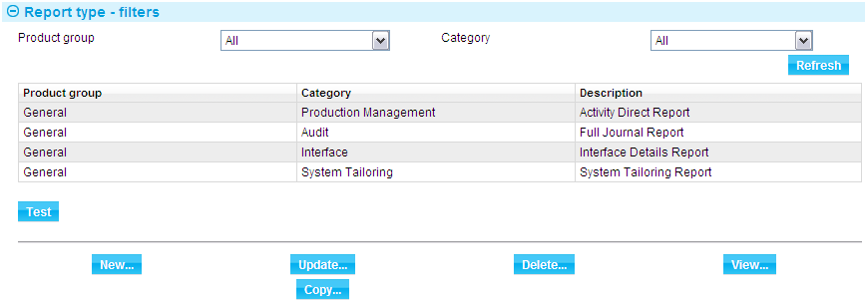

The system lists all the reports currently incorporated into the system. To incorporate a new report into the system, press the New button.

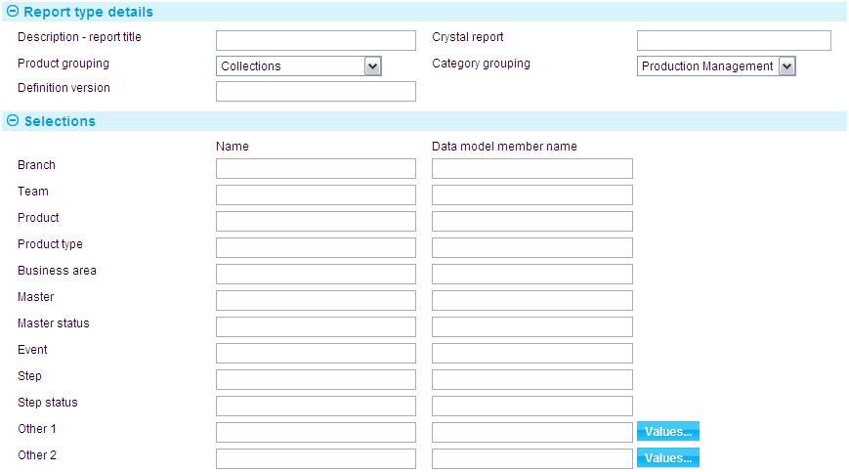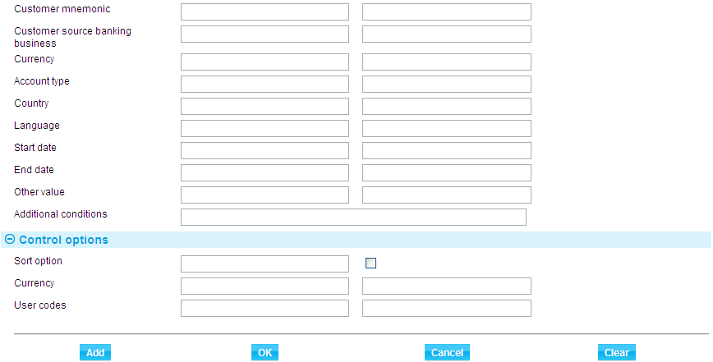

The following table explains what to enter into the fields in this window:

|  |  |  |
| --- | --- | --- |
|  | Fields | What to Enter |
|  | Description - Report Title | The name of the report. This is used to identify the report in the lists produced for users to select from at run-time. It is also used as the report header when the report is run (formula @ReportTitle). |
|  | Crystal Report | The name of the Crystal Reports report file (including its '.rpt' extension) into the Crystal Report field. |
|  | Product Grouping | Specify the product to which the report relates. If it does not relate to a specific product, specify 'General' instead. |
|  | Category Grouping | Specify the category of report. |
|  | Definition Version | The version of the system you are running. This is passed through as formula @TIVersion. |

When you have completed defining the report, press the Add button. The new report is added to the list displayed in this window, and is available for the users to run immediately.

The fields in the Selections section allow you to set up filter fields (see page 29) and additional conditions (see page 31).

You can use the same Crystal Reports report file in more than one report definition, so long as they have a unique report title in the Description field (if for example you wanted the report to be available in several versions using different selection criteria or additional conditions).

### Amending Report Definitions

Once you have incorporated a report into the system, you are able to amend its definition, including any filter field information. When you select a report in the Report Type Maintenance window, the system displays existing information for that report. You can overtype any of the displayed values and add new filter fields or additional conditions. Press the Update button to save any changes you make. These changes take effect immediately.

### Deleting Report Definitions

To delete a report definition, first select it in the Report Maintenance window, then press the Delete button. The system displays information for the report and prompts you to confirm the deletion.

Press the Yes button to proceed with the deletion, or the No button to cancel it.

If you delete a report definition, the Crystal Reports .rpt file is unaffected, and remains available on your system for you to use to create future report definitions in the system. However, end users are unable to access and run it using the system.

If you delete a report that has been incorporated into a processing cycle end of day batch phase action mapping, as described in the Business Operations Guide – Trade Innovation, then the batch report profile and report action will be deleted from the system, and the report definition is removed from the batch phase action mapping automatically.

## Filter Fields

The system is delivered with a number of pre-defined filter fields (see page 25) which you can attach to reports. Each filter field that you attach to a report will have a corresponding field in the window used to run the report. These fields are of three types:

* Fields with drop-down lists that allow the user to select from pre-defined values, such as product names, that are the same for all installations
* Fields with browsers on them that allow the user to list and select from valid values that are specific to your system, such as customer mnemonics
* Fields into which the user enters a value, such as a date or a user ID

Each filter field is associated with a table column in the database. This is used at run-time to generate the record selection criteria that determine which data is to be included in the report. If the user makes selections in more than one field, these are combined by logically 'and'ing them, meaning that the records included in the report will match the selection criteria entered into all the fields.

When attaching filter fields to a report in the system, you must define:

* The label that will appear against the field when the user runs the report
* The corresponding table column in the database. This column must contain data of the appropriate type, and it must be in a table that was used when the report was designed in Crystal Reports

In addition to the pre-defined fields, you can define two further drop-down filter fields for each report, and a single additional ‘Other value’ input field. These can be used to allow users to make selections not supported by the standard fields.

1. Again, each of these fields must be associated with a table column that appears in the report, and for each field you can define the values that are to appear in the drop-down list.

### Standard Filter Fields

|  |  |  |
| --- | --- | --- |
| Field Name | Type | Purpose |
| Branch | Browser | To select a single main banking entity or leave the field blank to generate a spool file for all main banking entities within the request scope. If the field is left blank a report is generated per main banking entity configured in your system.  Alternatively select a single branch to generate a spool file for the selected branch. If the security officer has defined the user as being able to work only with transactions for their own branch, then that branch is used as the default, which the user cannot change. If your system has been configured to use a branch hierarchy then this information will be used to restrict which branches the user can access here. |
| Team | Browser | To select a single team, or leave the field blank to include information for all teams. |
| Product | Drop-down list | To select a single product, or  to show information for all products. |
| Product Type | Drop-down list | To select a single product type, or  to show information for all product types. |
| Business Area | Drop-down list | To select a single business area, or  to show information for all business areas. |
| Master | Input | To enter a reference to run the report for a single transaction, or leave the field blank to include transactions for all products selected in either the Business Area field or the Product field. If your system has been configured to use a branch hierarchy then this information will be used to restrict which masters the user can access here. |
| Master Status | Drop-down list | To select a value to run the report for master records with a particular status or  to run the report for master records regardless of status. Valid statuses for masters are listed in the Common Facilities User Guide – Trade Innovation. |
| Event | Drop-down list | If the user selects a product in the Product field, then the drop-down here will list all events associated with that product. The user can then select  to include information for all events associated with the product, or else select a single event to include information for that event only. |
| Step | Drop-down list | To select a value to run the report for event records with a particular step value(for example ‘Input’ or ‘Log’) or  to run the report for events regardless of the current step . |
| Step Status | Drop-down list | To select a value to run the report for event records with a particular step status (for example ‘Awaiting’ or ‘Completed’) or  to run the report for step records regardless of step status. |
| Customer mnemonic | Browser | In conjunction with a source banking business, select a single customer, or leave the field blank to include information for all customers. If your system has been configured to use a branch hierarchy then this information will be used to restrict which customers the user can access here. |
| Customer source banking business | Browser | Select the source banking business from which the Customer mnemonic can be selected. The banking business is required to identify a unique customer. |
| Currency | Browser | To select a single currency, or leave the field blank to include information for all currencies. |
| Account Type | Browser | You can select the account type to which this report applies. |
| Country | Browser | You can select a single country, or leave the field blank to include information for all countries. |
| Language | Browser | You can select a single language, or leave the field blank to include information for all languages. |
| Start Date | Input | If the user enters a date, the report is restricted to information for that date or later. |
| End Date | Input | If the user enters a date, the report is restricted to information for that date or earlier. |
| Reporting Currency | Browser | Control option. The user can run the report to show certain information in a particular currency. If no currency is selected, all amounts will be shown in their original currency. If your report calculates totals of amounts which may be in different currencies such as master amounts, a reporting currency must be specified or the totals will be incorrect.  If you wish to use this feature then the target report MUST have two extra formulae defined in it to receive settings from Trade Innovation, and then to be available within the report. These are @ReportingCurrency and @ReportCcyRate which will respectively be set to the reporting currency code and the spot rate from the main banking entity base currency to the user-chosen reporting currency. |

### Configuring Standard Filter Fields

Within the window used to configure reports, you can use the fields shown in the columns headed 'Name' and 'Data Model Member Name' to configure the pre-defined filter fields.



The pre-defined filter fields are listed elsewhere (see page 25), where the Data Model Member Name represents a real field in the database. Each filter field has a corresponding set of two fields in the window. For each pre-defined filter field you want to include in the report, first enter a value, up to 16 characters long, into the appropriate Name field. The value you enter here will be displayed as a label against the corresponding field in the window used to run the report.

See the table at the end of this section for the format of Data Model Member Names.

Then enter the name of the database table name and column name into the corresponding Data Model Member Name field. Any value the user enters into the filter field at run-time will be matched against values in the database column identified here. You can also enter the name of a formula here, provided that it has already been defined in the report in Crystal Reports.

1. For each filter field you want to include in the report, you must enter a value into both the Name field and the Data Model Member Name field. If you enter a value into the Data Model Member Name field, but do not enter a value into the corresponding Name field, then the filter field will be displayed, but disabled, at run-time.
2. Do not try to fill in blank filter fields on the Report Maintenance window for any of the standard reports delivered as part of the system. These reports are delivered with all possible filters specified, and you cannot modify a standard delivered report by filling in a blank filter field.

There are restrictions on what you can enter into the Data Model Member Name field if the filter is to work properly when the report is run:

* The table containing the column must have been included in the report design in Crystal Reports, although the column itself or any associated formulae do not have to be displayed in the report to be used here.
* The database column must hold the correct type of data for the filter field, and any formulae must also result in data of the appropriate type for the filter field. The table at the end of this section explains what type of data is appropriate for each filter field. Consult the Data Model Viewer for information on what columns you can use in which fields.

1. When you enter the table and column names, do not enclose them in curly { } brackets. These are automatically added by the system.

|  |  |
| --- | --- |
| Filter Field | What it Must Contain |
| Branch | Branch code normally in a foreign key, for example MASTER.INPUT_BRN. |
| Team | Team code, normally in a foreign key for example MASTER.WORKGROUP. |
| Product | The code of a product exemplar, for example PRODUCT.CODE79 (note that the table is called EXEMPL30, but has been renamed as described on page 14 to PRODUCT). |
| Product Type | The code of a product type, for example PRODTYPE.CODE. |
| Business Area | The ID of a business area, for example BUSINE21.ID. |
| Master | The reference of a specific master, for example MASTER.MASTER_REF. |
| Master Status | Status of a master, for example MASTER.STATUS. |
| Event | The code of an event exemplar, for example EVENTTYPE.CODE79 (note that the table is called EXEMPL30, but has been renamed as described on page 14 to EVENTTYPE). |
| Step | A field of type step_type, for example EVENTSTEP.TYPE. |
| Step Status | A field of type step_status, for example EVENTSTEP.STATUS. |
| Customer | Customer, either from the customer table itself, or a foreign key to customer on any other table, for example GFPF.GFCUS1 or PARTYDTLS.CUS_MNM**.** Note that the source banking business that the customer belongs to should also be set. |
| Customer source banking business | The source banking business that the customer belongs to should also be set, for example GFPF.GFCUS1_SBB or PARTYDTLS.CUS_SBB. This means that the field Customer source banking business must also be included in the report definition if the Customer field is used. |
| Currency | Currency code, normally in a foreign key, for example MASTER.CCY. |
| A/c Type | Account type code or foreign key, for example POSTING.ACC_TYPE. |
| Country | Country code or foreign key, for example PARTYDTLS.COUNTRY. |
| Language | Language code or foreign key, for example PARTYDTLS.LANGUAGE. |
| Start Date | Any date field, for example BASEEVENT.TIMESTART. This generates a formula segment using a greater-than-or equal comparison, for example {BASEEVENT.TIMESTART} >= Date (2012, 10, 28). |
| End Date | Any date field, for example BASEEVENT.TIMESTART. This generates a formula segment using a less-than-or equal comparison, for example {BASEEVENT.TIMESTART} <= Date (2012, 10, 28). |

### Configuring Additional Filter Fields

The system permits you to set up three additional fields to allow the user to make selections not supported by the standard fields. These include:

* An input field, for use in cases where the user is expected to enter a valid value for an item, rather than selecting one item from a list
* Two drop-down lists, to allow the user to select from a list of values specific to that report. You can set up the values to appear in the report

#### The Input Field

In the fields used to define the single input field use the first field to enter a label for the field, then enter the name of the data model table and column name into the second field.



The same rules apply when entering values into these fields as for the pre-defined filter fields.

#### The Drop-down Lists

In the fields used to define the two additional drop-down filter fields, use the first field on each line to enter a label for the field, then enter the name of the data model table and column name into the second field. The same rules apply when entering values into these fields as for the pre-defined filter fields, with the further constraint that additional filter fields can only be used with database fields that hold, and formulae that return, string values.

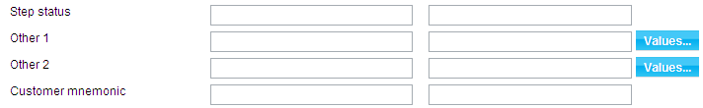

When you press the Values button, the system displays a window that allows you to set up the entries that will appear in the drop-down list for the filter.

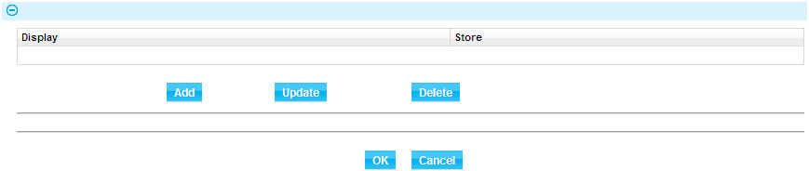

Each entry in the drop-down list consists of two parts:

* The text that appears in the drop-down list
* A corresponding value which the system looks for in the database at run-time

These correspond to the display value and the stored value respectively of a string field (see page 17).

To define the first entry in the drop-down list press Add.

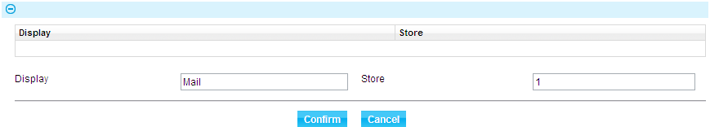

In the window that appears enter the text string that will appear in the drop-down list into the Display field, and the corresponding value that the system will search for in the database into the Store field.

Press **Confirm** to save the entry and close the window. The system adds the new values to the list for that field.

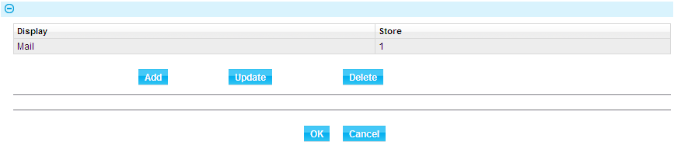

Repeat the process until you have defined all the entries that are to appear in the drop-down list.

1. When defining a drop-down list, bear in mind that entries will appear in the drop-down list in the same order in which they are listed in this window.

You can amend and delete entries in the usual way.

### Saving Additional Filter Field Information

When entering, amending or deleting additional filter field information you must use the Add, Update and Delete buttons within the Other Field Values window to save any new information you enter or any amendments or deletions you make.

1. Once you have closed this window you must then also press the Update button in the Report Maintenance window to save any new information, amendments or deletions as part of the report definition.

### Using Additional Filter Fields to Set Options

In addition to allowing you to configure reports to provide a selection based on database values, the additional filter fields also allow you to set up formula-based options, for example to permit the user to run either a detailed or a summary version of the report.

Additional filter fields set up as selections based on database values use the Crystal Reports 'set selection' function. Additional filter fields set up to provide options use the 'set formula' function instead.

To set up an additional filter field to provide an option, first define the formula in the usual way. As with all Crystal Reports formulae, the name of this formula will begin with an 'at' symbol (@).

Then, in the Other 1 or Other 2 field (as appropriate), enter the formula name in the Data Model Member Name field, preceded by a @.



This @ signals to the system that the value in the Data Model Member Name field is to be treated as a formula rather than a data model field name, and must be present.

In the window used to set drop-down values on the filter field, you may then set up options similar to those shown in the following illustration:

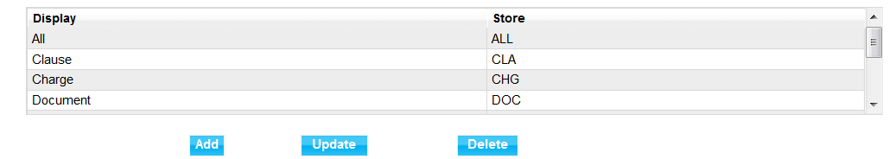

Your formula would have been defined to take account of the 'stored' values entered, providing a different layout depending on the option the user selects. The formula must be defined within the report if the report is to be run without error.

## Additional Conditions

You can use the Additional Conditions field to define additional record selection conditions using Crystal Reports formula syntax. These conditions are fixed conditions which the user cannot modify when running the report. They are appended to the record selection criteria set using the filter fields with a logical 'and'. They allow you to filter out information that is not relevant to the report, but cannot be filtered out in any other way, for example, to ensure that a report includes transactions with (or without) a certain status only.

Finastra recommend that you define additional conditions first in Crystal Reports using the Report|Select Expert menu option to enter a formula, then copy and paste it from Crystal Reports into the Additional Conditions field in the system. This enables you to test the formula in Crystal Reports before incorporating it into the system.

1. Make sure that you delete any formulae you create in this way from within the Crystal Reports report definition.

Note that, when entering formulae into the Additional Conditions file, you must include database table and column names in curly brackets and wrap literals using single quotation marks, as in the following example:

* {MASTER.STATUS} = 'LIV'

## Additional Capabilities

Reports run within the system include certain characteristics associated with the filter fields utilised. Common functionality is as follows:

* Reports which select by customer mnemonic use the associated customer source banking business to identify the customer uniquely.
* Where reports use base currency, this is the Main Banking Entity base currency.
* Where reports use local currency, this is the Branch local currency.

Additional characteristics are dependent on whether the report is scheduled with in a processing cycle end of day or run by a user within the zone.

## Report Profiles Mapped within Processing Cycles

Reports mapped into processing cycle end of day phases include the following characteristics:

* Reports including a branch filter allow a main banking entity or branch within the processing cycle scope to be defined.
* If no branch/entity is selected, a separate spooled output report is created for each main banking entity within the processing cycle scope. All branches within each entity are included.
* If a main banking entity is selected, one spooled report is created for all the branches in the entity.
* If a branch is entered, one spooled report is created for that branch. Lower branches in the hierarchy are not included.
* For reports requested in end of day by a user, the user’s teams/roles enquiry scope is not applicable. All selected data is included.

## Reports Requested by Daily Users

Reports requested by daily users within the zone include the following characteristics:

* Reports including a branch filter allow a main banking entity or branch within the zone to be defined.
* If no branch/entity is selected, a separate spooled output report is created for each main banking entity within the zone within the user’s teams/roles enquiry scope. All branches within each entity and within the user’s scope are included. Product events and step content is restricted to the requesting user’s scope.
* If a main banking entity is selected, one spooled report is created for all the branches in the entity within the user’s teams/roles enquiry scope. Product events and step content is restricted to the requesting user’s scope.
* If a branch is entered, one spooled report is created for that branch. Lower branches in the hierarchy are not included. Product events and step content is restricted to the requesting user’s scope.

## Testing Reports

You should test reports once you have incorporated them into the system to check that:

* Any filter fields appear with the correct labels and, for additional filter fields, with the correct values in the drop-down list
* The report produces the data you expect
* Select the report, then press the Test button.

The system displays the same window users will see when they run the report. Run the report from within this window to test that the report produces the expected data for all combinations of selection criteria, taking into account any additional conditions that are set up for the report.

1. For instructions on using this window to preview and print reports and write them to file see Reports – Trade Innovation.

### Errors

If you have made an error when configuring the standard filter fields or additional conditions, Crystal Reports will display the following error message when you try to run the report:

Error in formula

If this occurs, check whether the message appears if you run the report without entering selection criteria into any of the filter fields.

* If so, then the error is to be found in the value entered into the Data Model Member Name field for one or more of the filter fields. Test each filter field in turn by running the report with values set up for just one filter at a time until the error message recurs
* If not, then the error is to be found in any additional conditions set up for the report

# User-definable Fields and Codes for Statutory Reporting

This chapter explains how to create reports using the user-definable fields and codes for statutory reporting.

## Overview

The data stored by the system during transaction processing is expected to meet most reporting needs. However, to ensure that the system can meet all reporting requirements, including statutory reporting for outside agencies such as a central bank, the system provides additional mechanisms to allow you to categorise transaction data for analysis and reporting:

* User-definable fields
* Codes for statutory reporting

## User-definable Fields

The system permits you to define for each product up to five fields for accounting and analysis purposes. You can set the fields up differently for each product.

Each field consists of a name, which you provide, and a drop-down list, the values in which you also provide. These fields are displayed when a transaction is created or amended, allowing the user to select a value in each field.

In this way, each master record can be assigned up to five values that can be used for reporting purposes. You must set up a default value for each field to ensure that every transaction is included in reports that use the values in that field.

Your own bank's procedures govern the setting up of these user-definable fields, and their subsequent application to master records.

For information on defining these fields see the System Tailoring User Guide – Trade Innovation.

### Using User-definable Fields in Reports

You can design reports which provide totals according to the values entered into the five user-definable fields against transactions. To implement user codes in a report you must add the tables MASTER and USEROPTN to the report and join between the chosen one of five user codes that represents the correct reporting range.

You need to ensure that joins are made only between MASTER and USEROPTN where the chosen user option has actually been implemented in your environment.

## Statistics Codes for Statutory Reporting

The system permits you to define a list of reporting codes to be shown in the Settlement window during transaction processing. These codes can be used for statutory reporting and other forms of statistical analysis of payments.

The system permits the input clerk to enter up to five of these pre-defined codes against the payment lines for that event. Each reporting code attached in this way creates a reporting record that includes the reporting code itself and details of the payment line to which it is attached. Up to five records can be created for an event in this way. The input clerk can use the same reporting code more than once, and can apply more than one reporting code to the same payment line.

To use this functionality, your bank must have set the COEAnalysisRequired system option, as described in the System Tailoring User Guide – Trade Innovation.

For information on defining these fields see the Static Data Maintenance User Guide. For information on using them, see the Common Facilities User Guide – Trade Innovation.

### Using Statistics Codes in Reports

If you use the statutory reporting code functionality, each event entered onto the system can have up to five COE_RECORD records attached to it, each consisting of a reporting code and the details of the payment line against which it was entered.

To create a report using these reporting codes, you need to join the table event to the table COE_RECORD and from there on to the Statistics table (**COECODE**). The link to create is **COE_RECORD.COE_STATK** to **COE_CODE.STAT_KEY**.

# Handling New Releases

This chapter explains what you must do whenever a new version of the software is installed.

## Changes to the Data Model

You should follow the procedure outlined below whenever a new version of the system is installed to ensure that your custom reports will still work with the new version of the data model.

The procedure identifies reports that are no longer compatible with the new data model. You should then use Crystal Reports facilities to amend any such reports.

Open each of your reports in Crystal Reports in turn and select the Database|Verify Database menu option. If there are no compatibility problems between your report and the new data model, Crystal Reports will display a message saying:

The database is up to date

You need do nothing further to ensure that your report will run successfully with the new version of the system.

However, if there are incompatibilities, Crystal Reports will display one or more messages identifying the tables that have changed and giving you the option to amend the report layout automatically to reflect the changes. These facilities are documented in the Crystal Reports user guide.

One aspect of the function is not automatic, namely where a field that is used in a join is changed or removed. In this case, the link involved will simply be removed. After using the verify function you should use the Visual Linking Export to ensure that all tables are still joined. If there are any tables left as 'orphans' then any attempt to preview the report may give the error message 'Unsupported', meaning that the SQL query is incompatible with the fields required on the report.

Once you have used these Crystal Reports facilities you should test each report afterwards in Crystal Reports to ascertain the extent of any changes to the report layout (for example, to identify missing columns) resulting from the automatic amendments, and then make any further amendments yourself to compensate for them.

If a report needs to be amended (either automatically or manually) in Crystal Reports because of incompatibilities with the new version of the data model, you should then also use the system tailoring facilities to check that any filter field settings are still valid.

# Appendix A Party Roles Delivered with Trade Innovation

This appendix lists the party roles delivered with the system.

## Billing and Invoicing

The following party role is defined for billing and invoicing masters:

|  |  |
| --- | --- |
| BIP | Billing party |

## Clean Bankers' Acceptances

The following party roles are defined for clean banker's acceptance masters:

|  |  |
| --- | --- |
| DOB | Draft owner/beneficiary |
| OBL | Obligor |

## Clean Payments

The following party roles are defined for clean payment masters:

|  |  |
| --- | --- |
| STP | Send to |
| BEN | Beneficiary |
| RFP | Received from |

## Collection Orders

The following party roles are defined for collection order masters:

|  |  |
| --- | --- |
| DRW | Drawer |
| DRE | Drawee |
| PYE | Payee |
| TPT | Third party |
| CNS | Consignee |
| INE | In Case of Need |

The following party roles are defined for collection order Receive Documents event:

|  |  |
| --- | --- |
| RCD | Other received from party |

The following party roles are defined for collection order Payment event:

|  |  |
| --- | --- |
| OBB | Beneficiary bank |

## Export Credit Agency Facility

The following party roles are defined for export credit agency facility masters:

|  |  |
| --- | --- |
| DCUS | Deal customer |
| DECA | Export credit agency |

## Export Letters of Credit

The following party roles are defined for export letters of credit masters:

|  |  |
| --- | --- |
| APP | Applicant |
| BEN | Beneficiary |
| REB | Reimbursing bank |
| THB | Through bank |
| AVW | Available With bank |
| DDO | Drafts Drawn On bank |
| ISS | Issuing bank |
| RFB | Received From bank |
| ADV | Next advising bank |
| OBB | Other Beneficiary bank |

The following party roles are defined for export letters of credit payment events:

|  |  |
| --- | --- |
| PBB | Presenting party |
| TPB | Transfer presenting party |
| TPR | Transfer - other presenting party |

The following party role is defined for export letters of credit Outstanding Presentation events:

|  |  |
| --- | --- |
| RPT | Response From party |

## Export Guarantees

The following party roles are defined for export guarantee masters:

|  |  |
| --- | --- |
| APB | Principal bank |
| APP | Applicant |
| BEN | Beneficiary |
| REB | Reimbursing bank |
| THB | Through bank |
| AVW | Available With bank |
| DDO | Drafts Drawn On bank |

The following party roles are defined for export guarantee payment events:

|  |  |
| --- | --- |
| PBB | Presenting party |
| TPB | Transfer presenting party |
| TPR | Transfer - other presenting party |

The following party role is defined for export guarantee Outstanding Presentation events:

|  |  |
| --- | --- |
| RPT | Response From party |

## Export Standby Letters of Credit

The following party roles are defined for export standby letter of credit masters:

|  |  |
| --- | --- |
| APP | Principal |
| APB | Applicant bank |
| BEN | Beneficiary |
| REB | Reimbursing bank |
| THB | Through bank |
| AVW | Available With bank |
| DDO | Drafts Drawn On bank |

The following party roles are defined for export standby letters of credit payment events:

|  |  |
| --- | --- |
| PBB | Presenting party |
| TPB | Transfer presenting party |
| TPR | Transfer - other presenting party |

The following party role is defined for export standby letters of credit Outstanding Presentation events:

|  |  |
| --- | --- |
| RPT | Response From party |

## Financing

The following party roles are defined for financing masters:

|  |  |
| --- | --- |
| FTP | Finance To party |
| DBP | Debit party |

## Free Correspondence

The following party roles are defined for free correspondence masters:

|  |  |
| --- | --- |
| CPR | Correspondent |
| CPS | Correspondent |

## Import Guarantees

The following party roles are defined for import guarantee masters:

|  |  |
| --- | --- |
| APP | Principal |
| APB | Principal bank |
| BEN | Beneficiary |
| REB | Reimbursing bank |
| THB | Through bank |
| AVW | Available With bank |
| DDO | Drafts Drawn On bank |

If the guarantee involves a counter-guarantee, the following party roles are also defined:

|  |  |
| --- | --- |
| CIB | Counter gtee issuing bank |
| CPB | Counter gtee principal bank |

The following party roles are defined for import guarantee payment events:

|  |  |
| --- | --- |
| PBB | Presenting party |
| TPB | Transfer presenting party |
| TPR | Transfer - other presenting party |

The following party role is defined for import guarantee Claim Received events:

|  |  |
| --- | --- |
| OBB | Other beneficiary bank |

The following party role is defined for import guarantee Outstanding Claim events:

|  |  |
| --- | --- |
| RPT | Response from party |

## Import Letters of Credit

The following party roles are defined for import letters of credit masters:

|  |  |
| --- | --- |
| APP | Applicant |
| BEN | Beneficiary |
| REB | Reimbursing bank |
| THB | Through bank |
| AVW | Available With bank |
| DDO | Drafts Drawn On bank |
| ADV | Advising bank |
| APB | Applicant bank |
| DNB | Negotiating bank |

The following party roles are defined for import standby letters of credit payment events:

|  |  |
| --- | --- |
| PBB | Presenting party |
| TPB | Transfer presenting party |
| TPR | Transfer - other presenting party |

The following party role is defined for import letters of credit Claim Received events:

|  |  |
| --- | --- |
| OBB | Other beneficiary bank |

The following party role is defined for import letters of credit Outstanding Claim events:

|  |  |
| --- | --- |
| RPT | Response From party |

## Import Standby Letters of Credit

The following party roles are defined for import standby letters of credit masters:

|  |  |
| --- | --- |
| APP | Applicant |
| BEN | Beneficiary |
| REB | Reimbursing bank |
| THB | Through bank |
| AVW | Available With bank |
| DDO | Drafts Drawn On bank |
| ADV | Advising bank |
| APB | Applicant bank |
| DNB | Negotiating bank |

The following party roles are defined for import standby letters of credit payment events:

|  |  |
| --- | --- |
| PBB | Presenting party |
| TPB | Transfer presenting party |
| TPR | Transfer - other presenting party |

The following party role is defined for import standby letters of credit Claim Received events:

|  |  |
| --- | --- |
| OBB | Other beneficiary bank |

The following party role is defined for import standby letters of credit Outstanding Claim events:

|  |  |
| --- | --- |
| RPT | Response from party |

## Inward Cash Letter

The following party roles are defined for inward cash letter masters:

|  |  |
| --- | --- |
| RCP | Remitting bank |
| STP | Clearing bank |

## Licenses

The following party roles are defined for license masters:

|  |  |
| --- | --- |
| LPR | Principal party |
| LNP | Non-principal party |

## Outward Cash Letter

The following party roles are defined for outward cash letter masters:

|  |  |
| --- | --- |
| RCP | Payee |
| STP | Correspondent |

## Participations

The following party role is defined for participation masters:

|  |  |
| --- | --- |
| CUS | Deal customer |

The following party roles are defined for participation Amend events:

|  |  |
| --- | --- |
| PTA | Added participant |
| PTD | Deleted participant |
| PTU | Updated participant |

## Reimbursement Authorities

The following party roles are defined for reimbursement authority masters:

|  |  |
| --- | --- |
| ISR | Issuing bank |
| CLR | Claiming bank |
| DER | Drawee |
| DBR | Drawn By bank |

The following party role is defined for reimbursement authority Claim Received events:

|  |  |
| --- | --- |
| OCL | Other claiming bank |

## Shipping Guarantees

The following party roles are defined for shipping guarantee masters:

|  |  |
| --- | --- |
| CNS | Importer |
| SHP | Shipping company |

The following party role is defined for shipping guarantee Lodge Claim events:

|  |  |
| --- | --- |
| CLM | Claiming party |

The following party role is defined for shipping guarantee Settle Claim events:

|  |  |
| --- | --- |
| PYE | Payee |

## All Events

The following party role is defined for all events:

|  |  |
| --- | --- |
| OAD | Other addressee |

## Correspond Event (for all products)

The following party role is defined for the Correspond event for all products:

|  |  |
| --- | --- |
| CPT | Other addressee |

# Appendix B Report Views

The system provides database VIEWS in order to simplify the database structure for some of the operational reporting.

In database theory, a view is the result set of a stored query on the data, which the database users can query just as they would a persistent database collection object. This pre-established query command is kept in the database dictionary. Unlike ordinary base tables in a relational database, a view does not form part of the physical schema: as a result set, it is a virtual table computed or collated from data in the database, dynamically when access to that view is requested. Changes applied to the data in a relevant underlying table are reflected in the data shown in subsequent invocations of the view.

Some of the more complex reports within the system combine multiple views in order to ultimately simplify the reporting data.

## Views Supplied

This section lists each of the views and provides details of its purpose and any related views that it references.

Details of the individual fields within each view can be seen when viewing the table within Crystal.

1. The view ccydtls does not support group currencies such as Euro and in currencies. If you wish to include support for group currencies, you may extend this view as required.

|  |  |  |
| --- | --- | --- |
| View Name | Description | Views Included |
| accountdetails | Basic details of account e.g. back office account number and branch |  |
| allcpmstrs | Clean Payment masters. Includes the Main Banking Entity to which the master’s Behalf of Branch belongs. |  |
| alljournal | Journal data including Maker Checker data. |  |
| allprodmstrs | Trade Finance and Supply Chain Finance masters. Includes the Main Banking Entity to which the master’s Behalf of Branch belongs. | allrptmstrs  allcpmstrs |
| allrlmstrs | Provides the reference numbers of all types of master that relate to the master being reported. | relmstrs  rshipgtees  rtransfers  rlnkdmstrs  rlcpartpns  rfnpartpns |
| allrptmstrs | Basic details about Trade finance and Supply Chain Finance masters, regardless of status. |  |
| allwlcparties | Details for all the parties on an event for use in Watchlist reports. Includes details of the residence, risk and parent countries for each party. | cpmsiparties  watchlistparties |
| attachpartn | Masters participated by the Participation Deal being reported. |  |
| balancedetails | Details of the net of all postings to an account by value date | postedpostings  accountdetails |
| base_rate | Details base rates by branch including start and end dates. |  |
| bschgsforrpt | Basic details charges attached to a transaction including the behalf of branch, status and action, the charge party, charge basis, schedule and collect amounts. | rptchgmst  rptmasters |
| bsmstliab | Total bank-shared liability amount outstanding for a master. |  |
| bsmstroamt | Outstanding amount for the master and rate to convert to base currency for the MBE of the behalf of branch on the master. | ccydtls |
| buyerlabel | The label to be used for the party in the role of ‘Buyer’. Derived from the product option ‘BuyerLabel’ relating to the branch parameter set. | prodsysopt |
| ccydtls | Spot rate details and decimal places for currency and main banking entity. |  |
| chgpayrec | Denotes whether a charge is to be paid to us (Receive) or paid out to a third party by us (Pay). |  |
| chgsbypty | Details at individual charge level for a party within each master. Includes the information from bschgsforrpt, plus the key to the event that originated the charge and the spot rates for the various amounts to convert to base currency. | bschgsforrpt  ccydtls,  rptparties,  prodshortname  prodlongname,  buyerlabel,  sellerlabel |
| cpaymstrs | A view which retrieves the keys of Clean Payment masters only, excluding all other types of master. |  |
| cpmsiparties | Details of parties. For example e.g the Account With and Settlement Customer parties attached to the master settlement instructions used by Clean Payment transactions. | cpaymstrs |
| diarymem | All scheduled and manually run diary entry keys. |  |
| diff_rate | Differential rates by branch, start date and end date. |  |
| domainmapkeystr | Used internally by the view timappings |  |
| evdomainlistkeystr | Used internally by the view timappings |  |
| eventccy | The currency of the amount of the transaction within this event. Where the event currency is blank, the master currency is provided. This may be the case for correspondence events where the currency is not mandatory. | allrptmstrs |
| eventshortname | The shortname of the event set in the event options or where a correspondence further ID is set for correspondence events this is provided instead. |  |
| eventstepnames | The names of the steps attached to events. |  |
| eventsteptstamps | The timestamps representing the start date/time and finished date/time of the steps attached to events, formatted in a standard way. |  |
| eventtstamps | The timestamps representing the start date/time and finished date/time of events, formatted in a standard way. |  |
| facmstoamt | Outstanding amount for the factoring master and rate to convert to base currency for the MBE of the behalf of branch on the master. | ccydtls |
| facpostingdtls | Used with the interface report for EQ3 exposures. Tables referenced: ktranhdr, ktranrcd, gzh973. |  |
| finaccrualdtls | Finance master interest amount, date and rate details for current interest period. | ccydtls  fincurint_rate |
| fincurint_rate | Provides the current base rate, differential rate or group rate on Finance Deals. | fmaster  base_rate  diff_rate  group_rate |
| finmstoamt | Outstanding amount for the financing master and rate to convert to base currency for the MBE of the behalf of branch on the master. | ccydtls  finrpayamt |
| finrpayamt | Used in finmstoamt to retrieve the amount repaid in a Finance repayment event. |  |
| fintierrate | Details of the tiers in a Finance Interest Schedule, including their base rate, differential rate or group rate. | fmaster  base_rate  diff_rate  group_rate |
| fmaster | Provides the start date in packed integer format of Finance Deals to select the applicable base and/or differential rates. |  |
| group_rate | Group rates including base rate code, start dates and end dates. | base_rate |
| gwycusts | Master records where the customer is a gateway customer. Customer may be the principal party or the non principal party, depending on the type of product. |  |
| interfacedetails | Details of postings made to the Back Office for use in the Interface Report. Amalgamates records from GZH971, GZH972, GZG361, GZG331, GZG891 and GZG461 |  |
| invmstoamt | Outstanding amount for the invoice master and rate to convert to base currency for the MBE of the behalf of branch on the master. | ccydtls |
| jrnltstamps | The timestamp representing the 'created at' date/time of journal entries, formatted in a standard way. |  |
| lctrfoamt | Outstanding amount for the combined LC and related transfer LC masters and rate to convert to base currency for the MBE of the behalf of branch on the master. | bsmstroamt  trflcoamt |
| licmstoamt | Outstanding amount for the license master and rate to convert to base currency for the MBE of the behalf of branch on the master. | ccydtls |
| mbesysopt | System option parameter set relevant to the reporting branch. |  |
| mbetfsysopt | System option parameter set relevant to the reporting main banking entity. |  |
| mstroamt | Outstanding amount for all types of master and rate to convert to base currency for the MBE of the behalf of branch on the master. | facmstoamt,  finmstoamt,  invmstoamt,  lctrfoamt,  licmstoamt,  partpnoamt |
| mstrprodtype | The product type of the master. Note that this view uses an outer join, allowing it to be joined using an inner join when linked within a report. |  |
| mstrteam | The responsible team of the master. |  |
| notetstamps | The timestamp representing the 'created at' date/time of notes attached to masters, formatted in a standard way. |  |
| orchdefkeystr | Used internally by the view timappings. |  |
| orchmapkeystr | Used internally by the view timappings. |  |
| partpnoamt | Outstanding amount for the participation master and rate to convert to base currency for the MBE of the behalf of branch on the master. | ccydtls |
| perdchgaccr | Details of periodic charges and the accruals generated. | mbetfsysopt |
| postedpostings | Details of all postings to an account | accountdetails  postedpostingssq |
| postedpostingssq | Details of accrual postings and event postings | postedaccruals |
| postedaccruals | Details of periodic charge accrual postings and finance accrual postings |  |
| prodbusarea | Business areas and the products that they are mapped to. If included in a report, allows filtering by a business area that the user can enter as a filter. |  |
| prodevtnames | The long and short names of the product being reported. Derived from the system options ‘LongName’ and ‘ShortName’. | prodshortname  prodlongname |
| prodlongname | The long name of the product being reported. Derived from the system option ‘LongName’. | zonesysopt |
| prodshortname | The short name of the product being reported. Derived from the system option ‘ShortName’. | zonesysopt |
| prodsysopt | Product option parameter set relevant to the reporting branch. | mbesysopt |
| ptnedmstrs | Links to participation masters for both LCs, standbys and guarantees and financing. | rptnlcs,  rptnfns |
| ptppercent | Participation amounts and percentages. |  |
| relevmapkeystr | The autokey of a release event map converted to a string. Intended for use in System Tailoring reports where a unique identifier is required. Crystal does not support large numeric fields such as the entity autokeys so this view supplies the autokey of a release event mapping record as a string. |  |
| relmstrs | Master references of a related master for master being reported. |  |
| rfnpartpns | Master references of participations for finance master being reported. |  |
| rlcpartpns | Master references of participations for non finance master being reported. |  |
| rlnkdmstrs | Provides the foreign key of related masters, e.g attached Licenses or Participations. |  |
| rlnkmmstrs | Provides the foreign key of main masters, e.g attached to a License or Participation. |  |
| rptchgmst | Product-specific buyer and seller for charges. Includes the master, product, input, behalf of and source banking business branches. | rptmasters |
| rptmasters | Basic details about each active (live) master. | allrptmstrs |
| rptnfns | Master reference of participation for finance master being reported. |  |
| rptnlcs | Master reference of participation for LC, standby or guarantee master being reported. |  |
| rptparties | Party name and address details including the customer mnemonic and source banking business, SWIFT address, country and group. |  |
| rshgmstrs | Links to shipping guarantee masters. |  |
| rshipgtees | Master references of shipping guarantees for master being reported. |  |
| rtransfers | Master references of transfer LCs for master being reported. |  |
| sellerlabel | The label to be used for the party in the role of ‘Seller’. Derived from the product option ‘SellerLabel’ relating to the branch parameter set. | prodsysopt |
| timappings | Used by the System Tailoring Report to retrieve details of release item mappings such as event posting maps, event document maps and workflow orchestrations. | timappingsbase  prodevtnames  orchdefkeystr  prodshortname  prodlongname  orchmapkeystr  evdomainlistkeystr  domainmapkeystr |
| timappingsbase | Provides core data relating to event release item mappings for the view timappings. | relevmapkeystr |
| totpchgaccr | The total of periodic charges accrued to date as a group by view to retrieve the total accrual amount as a single row per charge. | perdchgaccr |
| trflcoamt | Outstanding amount for the transfer LC master and rate to convert to base currency for the MBE of the behalf of branch on the master. | ccydtls |
| trinstrrep | Details of tracer event including the type, event reference and information specific to the different tracer types, e.g. Draft or Payment. | ccydtls |
| watchlistparties | Details for all the parties on an event for use in Watchlist reports. Includes details of the residence, risk and parent countries for each party. |  |
| zonesysopt | Link to zone level system options. |  |

## Reports List

This section lists each of the reports delivered with the system and lists the views and tables used by those reports.

Each entry shows both the physical name and the alias name that is shown within Crystal for the table or view used.

|  |  |  |
| --- | --- | --- |
| Report Name | Report File Name | Table/View Name and Alias |
| A/c posting – Account and  A/c posting – Customer/Charge/SP | postings.rpt | “account” “account”  "c8pf" "c8pf"  “c5pf” “c5pf”  “gfpf” “gfpf”  “postedpostings” “postedpostings” |
| Activity | eventactivity.rpt | "allrlmstrs" "allrlmstrs"  "baseevent" "baseevent"  "businessarea" "businessarea"  "capf" "capf"  "ccydtls" "crmccy"  “eventccy” “eventccy”  “eventshortname” “eventshortname”  “eventstep” “eventstep”  “eventstepnames” “eventstepnames”  "eventtstamps" "eventtstamps"  "exempl30" "eventtype"  "rptparties" "npcp_party"  "rptparties" "pcp_party"  "prodshortname" "prodshortname"  "exempl30" "product"  "rptmasters" "rptmasters"  "workgr44" "team" |
| Billed Charges | billextchgdets.rpt | “billedchgdtls” “billedchgdtls” |
| Credit Approval History | crmhistory.rpt | "allrptmstrs" "allrptmstrs”  "baseevent" "baseevent"  "prodbusarea" "businessarea"  "c8pf" "c8pf"  "capf" "capf"  "ccydtls" "crmccy"  "gfpf" "crmcust"  "ccydtls" "eventccy"  “eventstep” “eventstep”  “eventstepnames” “eventstepnames”  "eventtstamps" "eventtstamps"  "eventsteptstamps" "eventsteptstamps"  "exempl30" "eventtype"  "exempl30" "product"  "mstrprodtype" "mstrprodtype"  "mstrteam" "mstrteam"  "officer" "officer"  "prodlongname" "prodlongname"  "rptparties" "npcp_party"  "rptparties" "pcp_party"  "ticrm01" "ticrm01"  "tidataitem" "crmtid" |
| Diary Exceptions | diaryexceptions.rpt | "capf" "capf"  "ccydtls" "ccydtls"  "exempl30" "product"  "note" "note"  "notetid" "notetid"  "notetstamps" "notetstamps"  "notety24" "notetype"  "prodlongname" "prodlongname"  "prodshortname" "prodshortname"  "rptmasters" "rptmasters"  "rptparties" "pcp_party"  "tidataitem" "notetid"  "workgr44" "team" |
| Finance Accruals | financeaccruals.rpt | "attachpartpn" "attachpartpn"  "prodbusarea" "businessarea"  "capf" "capf"  "exempl30" "product"  "finaccrualdtls" "finaccrualdtls"  “fintierrate” “fintierrate”  "ccydtls" "mstrccydtls"  "mstrprodtype" "mstrprodtype"  "prodlongname" "prodlongname"  "ptpercent" "ptpercent"  "rptmasters" "rptmasters"  "rptparties" "rptparties" |
| Full Journal Report | jrnfull.rpt | “alljournal” “alljournal” |
| Interface Details Report | eq3dets.rpt | "interfacedetails" "interfacedetails" |
| Limit/Facility Exposure Interface | expodets.rpt | "facpostingdtls" "facpostingdtls" |
| Master Event History | mstevthist.rpt | "baseevent" "baseevent"  "capf" "capf"  "ccydtls" "ccydtls"  “eventccy” “eventccy”  “eventshortname” “eventshortname”  “eventstep” “eventstep”  “eventstepnames” “eventstepnames”  "eventtstamps" "eventtstamps"  "exempl30" "eventtype"  "mstroamt" "mstroamt"  "prodlongname" "prodlongname"  "prodshortname" "prodshortname"  "exempl30" "product"  "rptmasters" "rptmasters"  “rptparties” “pcp_party” |
| Our Charges by Customer | chargesbycust.rpt | "prodbusarea" "businessarea"  "chgsbypty" "chgsbypty" |
| Our Charges by Master | chargesbymaster.rpt | "chgsbypty" "chgsbypty"  "prodbusarea" "businessarea"  "mstrteam" "mstrteam"  "reltemplte" "reltemplte" |
| Our Charges Details | eventcharges.rpt | "chgsbypty" "chgsbypty"  "prodbusarea" "businessarea"  "mstrteam" "mstrteam"  "baseevent" "origevent"  "baseevent" "owningevent"  "reltemplte" "reltemplte" |
| Outstanding Activity | outstactivity.rpt | "allrlmstrs" "allrlmstrs"  "prodbusarea" "businessarea"  "capf" "capf"  "exempl30" "product"  "ccydtls" "liabccydtls"  "ccydtls" "mstrccydtls"  "rptparties" "pcp_party"  "prodlongname" "prodlongname"  "prodshortname" "prodshortname"  "prodtype" "prodtype"  “rptparties” “pcp_party”  "rptmasters" "rptmasters"  "workgr44" "team" |
| Outstanding Liabiliy | outstliab.rpt | "bsmstliab" "bsmstliab"  "c7pf" "c7pf"  "ccydtls" "ccydtls"  "exempl30" "product"  "prodshortname" "prodshortname"  "rptmasters" "rptmasters"  "rptparties" "rptparties"  "tapf" "tapf" |
| Outstanding Transactions Awaiting Approval | awaitingtrans.rpt | "allrptmstrs" "allrptmstrs”  "baseevent" "baseevent"  "prodbusarea" "businessarea"  "capf" "capf"  "ccydtls" "ccydtls"  “eventccy” “eventccy”  “eventshortname” “eventshortname”  “eventstep” “eventstep”  “eventstepnames” “eventstepnames”  "eventtstamps" "eventtstamps"  "exempl30" "eventtype"  "exempl30" "product"  "rptparties" "npcp_party"  "rptparties" "pcp_party"  "workgr44" "team" |
| Outstanding Transactions by Gateway Customer | ostransbygwy.rpt | "allrlmstrs" "allrlmstrs"  "prodbusarea" "businessarea"  "capf" "capf"  "ccydtls" "ccydtls"  "gwycusts" "gwycusts"  "lcmaster" "lcmaster"  "mstroamt" "mstroamt"  "prodlongname" "prodlongname"  "prodshortname" "prodshortname"  "prodtype" "prodtype"  "rptmasters" "rptmasters"  "rptparties" "rptparties" |
| Outstanding Transactions by Non Principal | ostransbynpr.rpt | "allrlmstrs" "allrlmstrs"  "prodbusarea" "businessarea"  "capf" "capf"  "ccydtls" "ccydtls"  "exempl30" "product"  "lcmaster" "lcmaster"  "mstroamt" "mstroamt"  "prodlongname" "prodlongname"  "prodshortname" "prodshortname"  "prodtype" "prodtype"  "rptmasters" "rptmasters"  "rptparties" "rptparties" |
| Outstanding Transactions by Principal | ostransbypri.rpt | "allrlmstrs" "allrlmstrs"  "prodbusarea" "businessarea"  "capf" "capf"  "ccydtls" "ccydtls"  "exempl30" "product"  "lcmaster" "lcmaster"  "mstroamt" "mstroamt"  "prodlongname" "prodlongname"  "prodshortname" "prodshortname"  "prodtype" "prodtype"  "rptmasters" "rptmasters"  "rptparties" "rptparties" |
| Periodic Charge Payment Report | payperdchgs.rpt | "bschgsforrpt" "bschgsforrpt"  "prodbusarea" "businessarea"  "capf" "capf"  "chgpayrec" "chgpayrec"  "diaryentry" "diaryentry"  “exempl30” “product”  "mstroamt" "mstroamt"  "mstrteam" "mstrteam"  "perdchgaccr" "perdchgaccr"  "prodlongname" "prodlongname"  "reltemplte" "reltemplte"  "rptmasters" "rptmasters"  "rptparties" "chg_party"  "rptparties" "npcp_party"  "rptparties" "pcp_party" |
| Periodic Charge Report | periodicchgs.rpt | "bschgsforrpt" "bschgsforrpt"  "prodbusarea" "businessarea"  "capf" "capf"  "rptparties" "chg_party"  "chgpayrec" "chgpayrec"  "eventchg" "eventchg"  "exempl30" "product"  "mstroamt" "mstroamt"  "perdchgaccr" "perdchgaccr"  "prodlongname" "prodlongname"  “reltemplate” “reltemplate”  "rptmasters" "rptmasters"  "transched" "transched"  "workgr44" "team" |
| System Tailoring Report | mappings.rpt | "criterion" "criterion"  "pty_rol" "pty_rol"  “timappings” “timappings” |
| Watch List Outstanding Checks | watchliststat.rpt | “allprodmstrs” “allprodmstrs”  “allwlcparties” allwlcparties”  "baseevent" "baseevent"  "capf" "capf"  “eventshortname” “eventshortname”  “eventstep” “eventstep”  "eventtstamps" "eventtstamps"  "exempl30" "eventtype"  "exempl30" "product"  "ofac" "watchlist"  "prodlongname" "prodlongname"  "prodtype" "prodtype"  "rptmasters" "rptmasters"  "workgr44" "team" |

## Departmental Limits Reports

|  |  |  |
| --- | --- | --- |
| Report Name | Report File Name | Table/View Name and Alias |
| Limit Categories | dlrcategory.rpt | “dltcategory” “dltcategory” |
| Country Limit Expiry | dlrctryexpiry.rpt | "c7pf" "c7pf"  "c8pf" "expsrccy"  "c8pf" "limctlccy"  "c8pf" "limdetccy"  "dltcategory" "dltcategory"  "dltexposures" "dltexposures"  "dltlimitcontrol" "dltlimitcontrol"  "dltlimitdetail" "dltlimitdetail"  "dltstructdetail" "dltstructdetail"  "dlttotal" "dlttotal"  "gfpf" "gfpf"  "spotrate" "expsrspt"  "spotrate" "limctlspt"  "spotrate" "limdetspt"  "tapf" "tapf" |
| Country Utilisation | dlrctryutil.rpt | "c7pf" "c7pf"  "c8pf" "expsrccy"  "c8pf" "limctlccy"  "c8pf" "limdetccy"  "dltcategory" "dltcategory"  "dltexposures" "dltexposures"  "dltlimitcontrol" "dltlimitcontrol"  "dltlimitdetail" "dltlimitdetail"  "dltstructdetail" "dltstructdetail"  "dlttotal" "dlttotal"  "gfpf" "gfpf"  "spotrate" "expsrspt"  "spotrate" "limctlspt"  "spotrate" "limdetspt"  "tapf" "tapf" |
| Customer/Group Limit Expiry | dlrcustexpiry.rpt | "c7pf" "c7pf"  "c8pf" "expsrccy"  "c8pf" "limctlccy"  "c8pf" "limdetccy"  "dltcategory" "dltcategory"  "dltexposures" "dltexposures"  "dltlimitcontrol" "dltlimitcontrol"  "dltlimitdetail" "dltlimitdetail"  "dltstructdetail" "dltstructdetail"  "dlttotal" "dlttotal"  "gfpf" "gfpf"  "spotrate" "expsrspt"  "spotrate" "limctlspt"  "spotrate" "limdetspt"  "tapf" "tapf" |
| Customer/Group Utilisation | dlrcustutil.rpt | "c7pf" "c7pf"  "c8pf" "expsrccy"  "c8pf" "limctlccy"  "c8pf" "limdetccy"  "dltcategory" "dltcategory"  "dltexposures" "dltexposures"  "dltlimitcontrol" "dltlimitcontrol"  "dltlimitdetail" "dltlimitdetail"  "dltstructdetail" "dltstructdetail"  "dlttotal" "dlttotal"  "gfpf" "gfpf"  "spotrate" "expsrspt"  "spotrate" "limctlspt"  "spotrate" "limdetspt"  "tapf" "tapf" |
| Limit Exception Report | dlrexcptctl.rpt | "c7pf" "c7pf"  "c8pf" "excptdetccy"  "c8pf" "oldexcptdetccy"  "dltcategory" "dltcategory"  "dltlimitcontrol" "dltlimitcontrol"  "dltlimitdetail" "dltlimitdetail"  "dltstructdetail" "dltstructdetail"  "dltstructure" "dltstructure"  "dlttotal" "dlttotal"  "dlwexceptcontrol" "dlwexceptcontrol"  "dlwexceptdetail" "dlwexceptdetail"  "gfpf" "gfpf"  "spotrate" "excptdetspt"  "spotrate" "oldexcptdetspt"  "tapf" "tapf" |
| Limit Setup | dlrlimitctl.rpt | "c7pf" "c7pf"  "c8pf" "limctlccy"  "spotrate" "limctlspt"  "c8pf" "limdetccy"  "c8pf" "newccylimdetccy"  "dltcategory" "dltcategory"  "dltlimitcontrol" "dltlimitcontrol"  "dltlimitdetail" "dltlimitdetail"  "dltstructdetail" "dltstructdetail"  "dltstructure" "dltstructure"  "dlttotal" "dlttotal"  "gfpf" "gfpf"  "spotrate" "limdetspt"  "spotrate" "newccylimdetspt"  "tapf" "tapf" |
| Limit Structures | dlrstructures.rpt | "dltcategory" "dltcategory"  "dltstructdetail" "dltstructdetail"  "dltstructure" "dltstructure"  "dlttotal" "dlttotal" |
| Limit Totals | dlrtotal.rpt | "dltcategory" "dltcategory"  "dlttotal" "dlttotal"  "dlttotal" "dlttotal_2"  "dlttotallink" "dlttotallink" |
| Utilisation Audit | dlrutilaudit.rpt | "c7pf" "c7pf"  "c8pf" "dltcmpntsccy"  "c8pf" "limdetccy"  "c8pf" "neweliglimdetccy"  "capf" "capf"  "dltcategory" "dltcategory"  "dltcomponents" "dltcomponents"  "dltexplinkage" "dltexplinkage"  "dltexposures" "dltexposures"  "dltlimitcontrol" "dltlimitcontrol"  "dltlimitdetail" "dltlimitdetail"  "dltreservation" "dltreservation"  "dltstructdetail" "dltstructdetail"  "dlttotal" "dlttotal"  "gfpf" "gfpf"  "spotrate" "dltcmpntsspt"  "spotrate" "limdetspt"  "spotrate" "neweliglimdetspt"  "tapf" "tapf" |

## Extending the Views

If you wish to include additional fields in a report that makes use of a View the supplied View can be modified.

The View SQL script called ‘rvcf.n.n.sql’ can be found in the folder specified for the location of the database scripts that were used to create or upgrade the database. Typically this will be ti\DB Scripts\reportsviews.

The scripts can be edited using any text based editor (such as Notepad).

It is recommended that you create an update script that only contains those views that you wish to modify.

For example to include additional data in the view of the currency table (view name *ccydtls*):

Copy ‘rvcf.n.n.sql’ to a new text file.

Remove all but the following details from the new file:

create view ccydtls (

ccy_code, mbe, ccy_spt, ccy_sei, ccy_ced

)

as (

select

c8pf.c8ccy, spotrate.branch, spotrate.spotrate, spotrate.reciprocal, c8pf.c8ced

from

c8pf, spotrate

where

c8pf.c8ccy = spotrate.currency

);

If you decided you wanted to add the currency full name (c8cur) to the view it can be modified as follows:

create view ccydtls (

ccy_code, ccy_name, mbe, ccy_spt, ccy_sei, ccy_ced

)

as (

select

c8pf.c8ccy, c8pf.c8cur, spotrate.branch, spotrate.spotrate, spotrate.reciprocal, c8pf.c8ced

from

c8pf, spotrate

where

c8pf.c8ccy = spotrate.currency

);

It is necessary to recreate the view within the database. This involves dropping the existing view and then recreating the view to include the new information.

The script for dropping views can be found in the folder specified for the location of the database scripts that were used to create or upgrade the database.

Select ‘rvdf.n.n.sq’.

Copy ‘rvdf.n.n.sql’ to a new text file.

Following the example above edit the copy of the file so it only includes the following view instructions:

drop view ccydtls;

Please refer to Chapter 4 - Database Setup in the Installation Guide for details on how to create the revised view details using the script runner. You will need to place the revised scripts into the script runner folder location specified when the script runner was last executed. This will then drop the view and create the new view.

Once the new view has been created in the database you can then modify the report to include details of any new fields added to the view. Any reports that have used the modified view will need to be verified using the instructions in Chapter 6 of this guide.

# Appendix C Crystal Reports Engine Error Codes

If an error occurs, the Crystal Report Engine will generate an error message to help you diagnose and correct the issue. The following list of error messages is taken from the standard Help file distributed with Crystal Reports Professional Developer Edition.

Many of these errors will only be raised during the development of a report, but the full list is shown for completeness.

Each error is displayed as a code number, which has an associated message text. These are given in the following table, ordered by code number, together with an explanation of the circumstances in which the error code is generated. Note that many of the errors are specific to the Windows platform:

|  |  |
| --- | --- |
| Error | Explanation |
| 500 (not enough memory) | There is not enough memory available to complete the call or an incorrect JDBC handle was specified. |
| 501 (invalid job no) | You have specified a job number that does not exist. |
| 502 (invalid handle) | You have specified a handle that does not exist. |
| 503 (string too long) | The string you are calling with PEGetHandleString is too long for the buffer allocated. If returned by other routines, it means that the string does not end with a null byte. |
| 504 (no such report) | You have specified a report that does not exist in the path. |
| 505 (no destination) | You have made the PEStartPrintJob call without first specifying a print destination. |
| 506 (bad file number) | You have tried to set an Nth file name and the file number you specified is out of the existing range. 0<= fileN< N files. |
| 507 (bad file name) | There is an error in the file name you specified. |
| 508 (bad field number) | The field number you specified is out of the existing range. 0<=fieldN<= N fields. |
| 509 (bad field name) | The program cannot add the field name you specified. |
| 510 (bad formula name) | The program cannot add the formula name you specified. |
| 511 (bad sort direction) | Sort direction must be either PE_SF_DESCENDING or PE_SF_ASCENDING. You have specified a sort direction other than those allowed. |
| 512 (engine not open) | The Report Engine must be open in order for the call to be successful. Your code is lacking a PEOpenEngine call. |
| 513 (invalid printer) | The printer driver for the printer you specified is missing or there is no default printer installed. |
| 514 (print file exists) | The name you have specified for the export file already exists. You must delete the file and export again or specify a different file. |
| 515 (bad formula text) | There is a formula error in the replacement formula text. Review the formula syntax and retry. This also returns the formula name and a formula message indicating the source of the error. |
| 516 (bad group section) | The group section you specified is now invalid in the report, i.e., a group is based on a formula field and the formula has changed so it is no longer suitable for basing a group on. |
| 517 (engine busy) | Only one application can access the Report Engine at one time. There is currently another application using the engine. |
| 518 (bad section) | You have given a bad value as the section code for some function like PESetGroupCondition. |
| 519 (no print window) | There is no print window available to make your call successful (for any call that depends on a print window already existing: PEGetWindowHandle, PECloseWindow, PEPrintWindow). |
| 520 (job already started) | You are trying to start a print job that has already been started. This can happen if you start a print job and then try to start printing again before the previous printing has finished. |
| 521 (bad summary field) | The summary field specified as a group sort field is invalid or non-existent. |
| 522 (not enough sys res) | There are not enough Windows system resources to process the function. |
| 523 (bad group condition) | You have specified an invalid group condition. |
| 524 (job busy) | You tried to initiate printing while Crystal Reports was already printing a job. |
| 525 (bad report file) | There is something wrong with the report you are trying to open. |
| 526 (no default printer) | You have not specified a default printer. Specify a default printer via the Windows Control Panel. |
| 527 (SQL server error) | Unable to connect to the Server or unable to successfully run the SQL query. Some of the most common reasons for the error to occur are:   * Database Driver DLLs cannot be found * LogOnInfo Parameters are not NULL terminated * Incorrect Logon Parameters. Ensure that the ServerName, DatabaseName, UserId, and Password are all valid for the server that you are trying to logon to * Incorrect structSize given for LogOnInfo Structure. If an incorrect value is given here, a SQL Server error may result. The correct value for the structSize is514 * Incorrect SQL Query or the query generated an JDBC error or server error |
| 528 (bad line number) | You have specified an invalid line number. |
| 529 (disk full) | When printing to file or when sorting, the program requires more room than is available on the disk. |
| 530 (file error) | In trying to print to file, the program is encountering another file problem besides disk full. |
| 531 (incorrect password) | You have specified an incorrect password. |
| 532 (bad database DLL) | The database DLL is corrupt. |
| 533 (bad database file) | Something is wrong with the database you have specified. You may need to verify using the Database|Verify Database command. |
| 534 (error in database DLL) | The database DLL is corrupt, missing or out of date. |
| 535 (database session) | You have attempted to log on using incomplete or incorrect session parameters. |
| 536 (database logon) | You have attempted to log on using incomplete or incorrect log on parameters. |
| 537 (database location) | The table you have specified cannot be found. |
| 538 (bad struct size) | The structure size of the structure parameter has not been set correctly. |
| 539 (bad date) | You have specified an invalid date using the PESetPrintDate function. |
| 540 (bad export DLL) | The DLL required by your export call is either missing or out of date. This error can also be caused by an invalid export options parameter. |
| 541 (error in export DLL) | An export DLL has reported an error. |
| 542 (prev at first page) | You are using the previous page control in the print window when you are already at the first page of the report. |
| 543 (next at last page) | You are using the next page control in the print window when you are already at the last page of the report. |
| 544 (cannot access report) | Access to report file denied. Another program or user may be using it. If an OLE-based report is already open in CRW and you are trying to open it via CRPE, the call will fail. |
| 545 (user cancelled) | The user clicked the cancel button. This error is also given if the target for the report output is unreachable (printer or file). |
| 546 (OLE2 not loaded) | The program cannot open the report (which includes an OLE 2.0 object) because OLE 2.0 cannot be loaded. |
| 547 (bad cross tab group) | You have specified an invalid row or column field in your Cross-Tab report. |
| 548 (no ct summarized field) | You are trying to run a Cross-Tab report without specifying a summarized field. |
| 549 (destination not export) | You have called PEDecodeExportOptions before first calling PEGetExportOptions. |
| 550 (invalid page number) | You have used an invalid page number with PEShowNthpage. |
| 552 (not stored procedure) | Returned by PESetNthParam when there is no table in the current report that is based on a stored procedure. |
| 553 (invalid parameter) | The parameter you have specified does not exist in the stored procedure, or the value you have entered is not valid for the specified parameter. |
| 554 (graph not found) | The graph specified for the section does not exist. |
| 555 (invalid graph type) | The graph type you have indicated with PESetGraphType is not valid. |
| 556 (invalid graph data) | Returned by PESetGraphData if:   * Either the report is a Cross-Tab, and colGroupN or rowGroupN is > 1 * Or the report is not a Cross-Tab, and rowGroupN is something other than PE_GRAPH_DATA_NULL_SELECTION or colGroupN+1 |
| 557 (cannot move graph) | Returned by PESetGraphData if the report is not a Cross-Tab, and colGroupN differs from the graph's current value for colGroupN. |
| 558 (invalid graph text) | Returned by PESetGraphText. The graph text structure PEGraphTextInfo contains an invalid entry. |
| 559 (invalid graph opt) | Returned by PESetGraphOptions. The graph options structure, PEGraphOptions contains an invalid entry. |
| 560 (bad section height) | Returned by PESetMinimumSectionHeight. The section height specified is either negative or 0; it must be a value greater than 0. |
| 561 (bad value type) | Returned by PESetNthParameterField. The valueType specified in the PEParameterFieldInfo structure is invalid for a parameter field. It must be one of the following: number, currency, Boolean, date, or string. |
| 562 (invalid sub-report name) | Returned by PEOpenSubreport. The subreport name passed does not exist. |
| 564 (no parent window) | Returned by PESetDialogParentWindow. The parent window handle specified is invalid. |
| 565 (invalid zoom factor) | Returned by PEZoomPreviewWindow. The zoom factor passed in the level parameter is invalid. It must be 0, 1, 2 >= 25, <= 400, or one of the defined constants. |
| 567 (page size overflow) | Returned if the total length of the page header and page footer is greater than the length allotted for a page. |
| 568 (low system resources) | Returned if GDI memory gets down to 10%. The program will give this message rather than GPF. |
| 570 (bad group number) | Returned when the user passes in an invalid group number. This can happen, for example, when the user passes an invalid group number to PEAddGroup. |
| 572 (invalid negative value) | Returned when the user passes in a negative value where a value greater than zero should be passed. This can happen, for example, when the user passes a negative section height to PESetMinimumSectionHeight. |
| 573 (invalid memory pointer) | Returned when the user passes in an invalid pointer, for example, an invalid structure pointer, an invalid string pointer, and so on. |
| 594 (invalid parameter number) | Returned when the user passes in an invalid parameter field number, for example, when the user passes an invalid parameter field number to PESetNthParameterField. |
| 599 (SQL server not opened) | Returned when the user passes invalid information to PELogonServer, or PELogOffServer. This can happen, for example, if the user does not specify the server name. |
| 999 (Not implemented) | Internal error. |

# Appendix D Configuring Crystal Designer to Use Java User Function Libraries

The following table cover additional notes relating to Java User functions:

|  |  |
| --- | --- |
| Item | Notes |
| Formula Editor –  1. The section Additional Functions in the Functions tree view is empty  2. The list of DLLs in the .Loaded Modules window accessed from the Help About window does not contain any Java runtime libraries and the only Java-related DLL present is jvmmanager.dll. | This may be caused by the presence of incompatible Java runtime systems and jar files on the classpath.  Note - On Windows systems, the active Java runtime is specified both in the environment variables and the Registry, to which are added Crystal's own settings in CRConfig.xml.  Care needs to be taken when changing these settings as you may affect other software packages.  Alternative approach:  Where it  is not feasible to set up a system for the sole purpose of editing reports, we recommend temporarily commenting out the calls to converttotimezone in the various reports that use this User Function whilst edits are made, then restoring the calls before the reports are made available to a runtime system. Note that the User Function is called correctly in the runtime even when not available to Crystal Designer. |